20/11/25
Django Rest Frame work
- Django
- Python
- HTTP Requests
- Djangi-cors-headers
- VS code

Create a python virtual env to isolate each one and activate the same
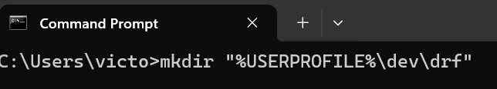
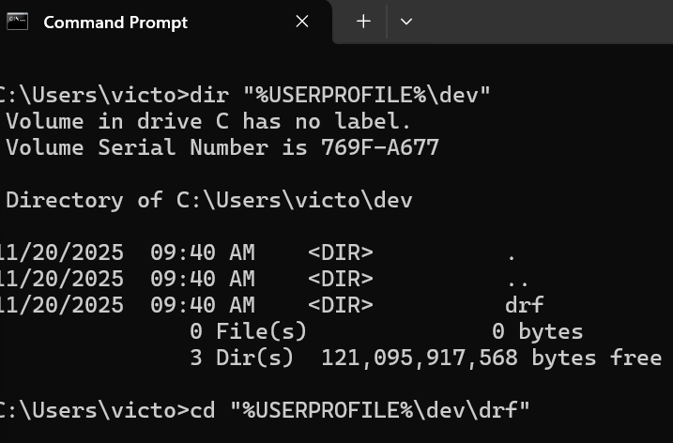
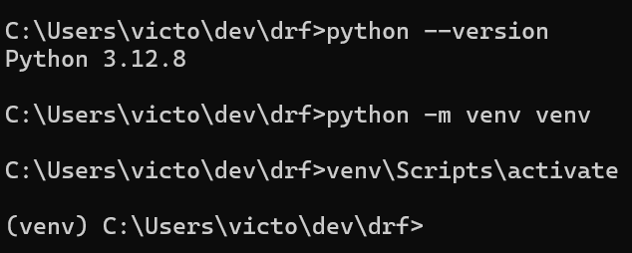
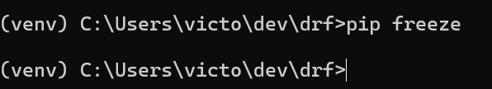

C:\Users\victo\dev\drf>venv\Scripts\activate
All ready to work!
Install all necessary packages
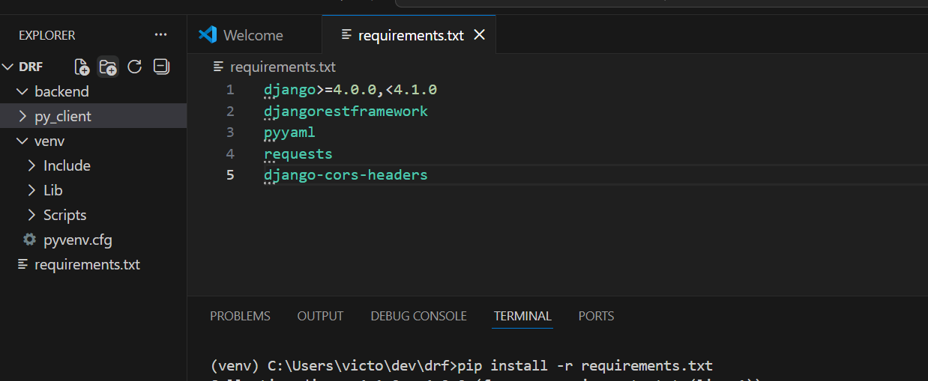

django-admin startproject cfehome . creates a new Django project in the current directory.
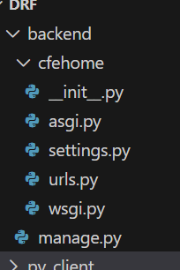
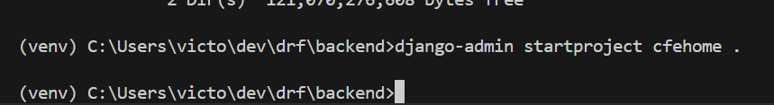
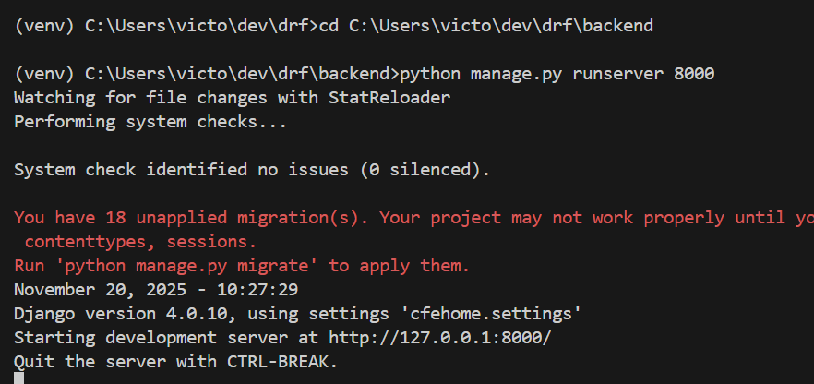

Creating a api view
python manage.py startapp api
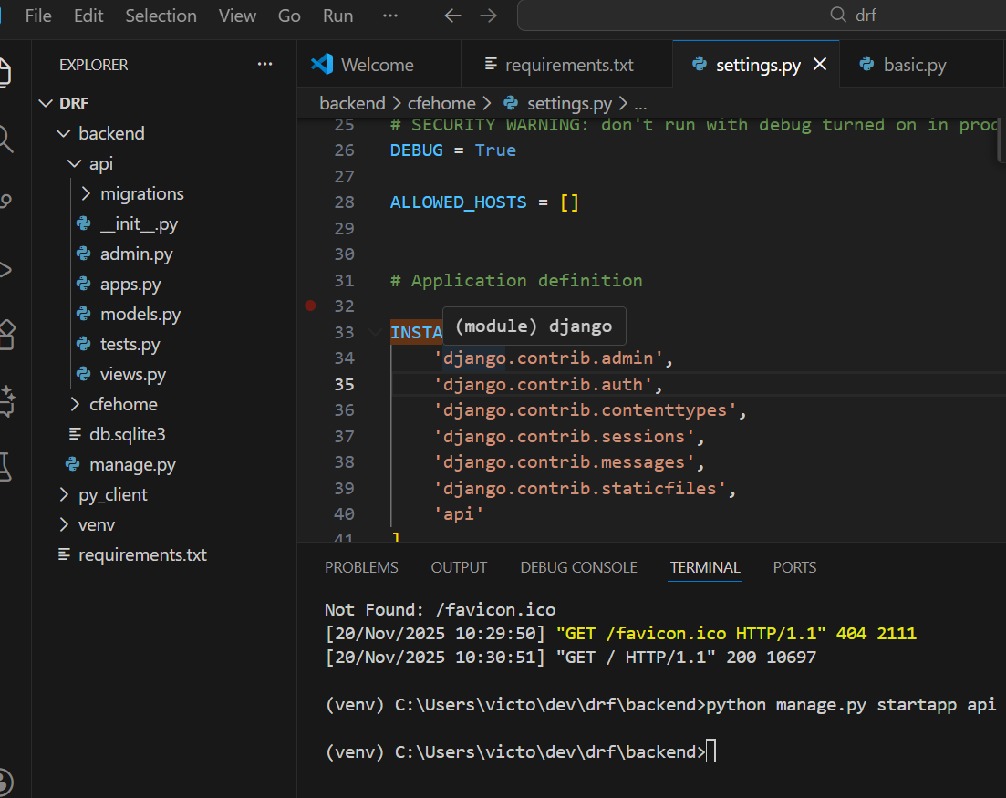
Settings.py
Added api in INSTALLED_APPS

Request–Response Lifecycle
Python client → Django router → view → response → logs

Step | Component | What Happens | File Name | One-Line Code / One-Line Output
1 | Python client | Sends HTTP request to Django | basic.py | requests.get("http://127.0.0.1:8000/api/")
2 | Django server | Receives incoming HTTP request | (Django internal) | (no explicit code — Django WSGI server handles this)
3 | URL router | Matches /api/ to the correct view | cfehome/urls.py | path('api/', include('api.urls'))
4 | View | Reads request body, prints it, returns JSON | api/views.py | print(request.body) → b'{"query": "Hello world"}'return JsonResponse({"message": "Hi there..."})
5 | Django response | Sends JSON back to Python client | (Django internal) | Response body → {"message": "Hi there, this is your Django API Response!!"}
6 | Python client | Receives + prints JSON response | basic.py | print(get_response.json()) → {'message': 'Hi there...'}
7 | Django | Logs the request in the console | (Django internal) | Log line → "GET /api/?abc=123 HTTP/1.1" 200 59

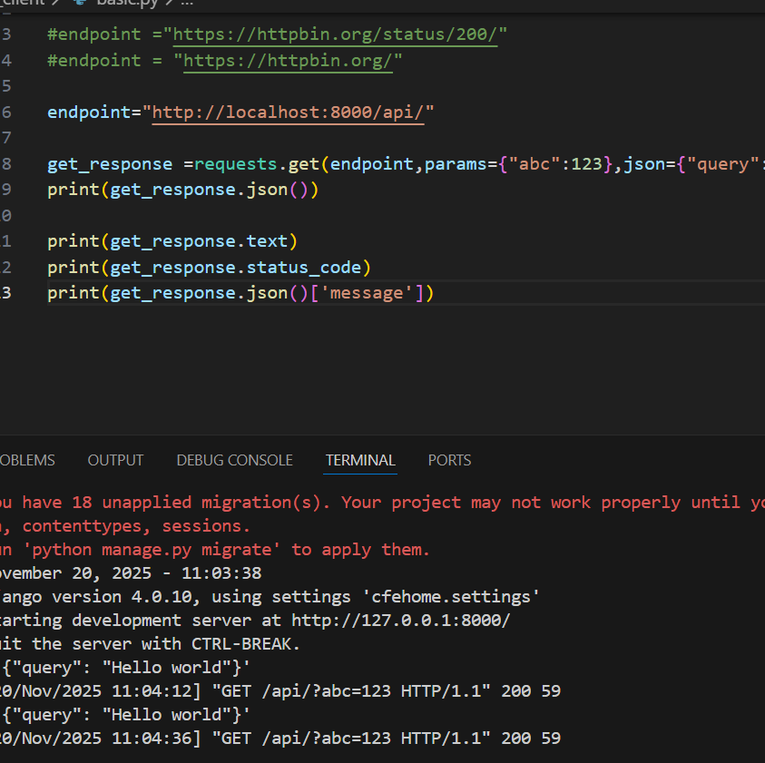
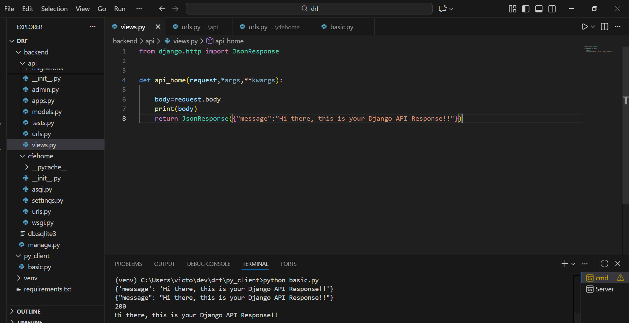

Django model Instance as an API Response

Creation of model
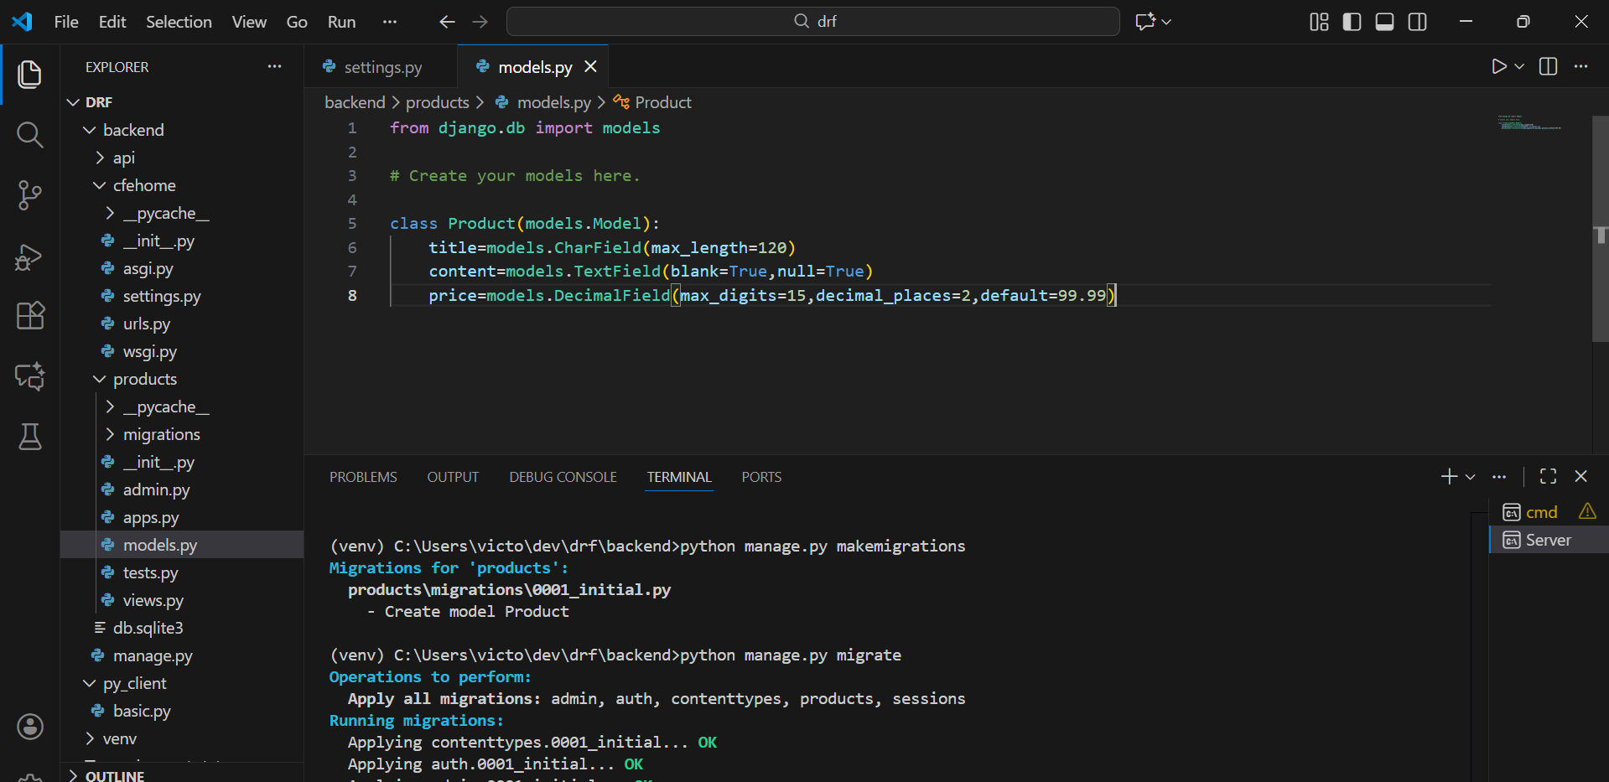
JSON is only used for sending data between systems.
The dictionary is used for working with data inside Python.
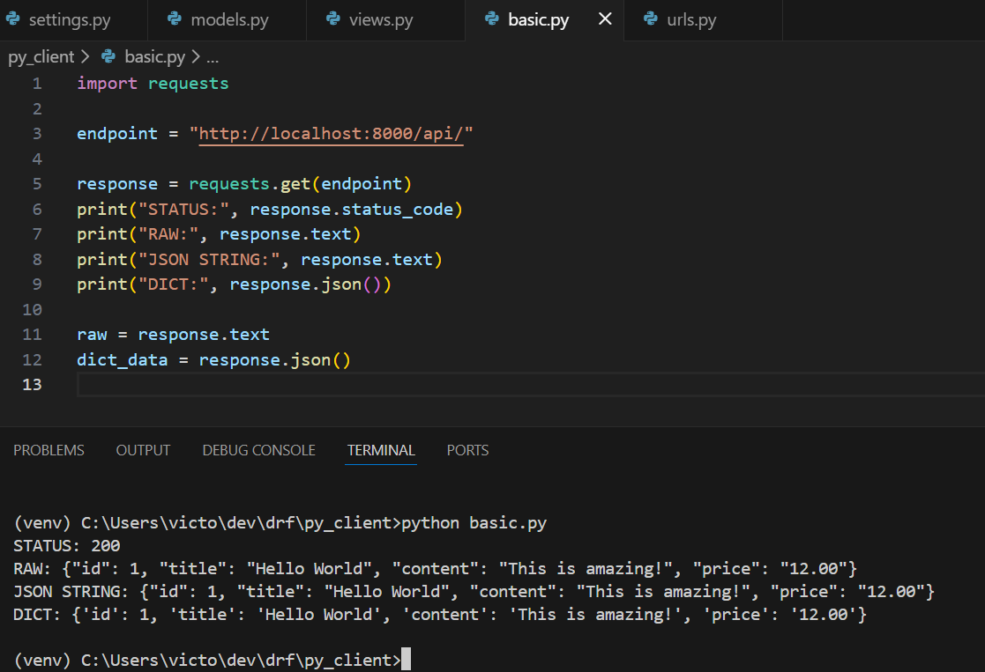

RAW it it like a string you cant perform or access it like
Response.text[‘id]]
RAW → dict is POSSIBLE ONLY IF the raw IS JSON
RAW → dict ONLY IF RAW contains valid JSON.
Eg raw: {"id": 1, "title": "Laptop"}
json.loads(raw) Works
Word | Meaning
RAW | Any text received from a server
JSON | Raw text that follows JSON rules ({} with key/value)
dict | Python object created after parsing JSON

Rest Framework View and Response
WHAT @api_view DECORATOR DOES ?
@api_view is a DRF decorator.
When you write:
@api_view(["GET", "POST"])
def api_home(request):
...
You are telling Django REST Framework:
“Make this function behave like an API endpoint.
Allow GET and POST requests to it.”
So:
- It turns a normal Django function
into
- a REST API function.

WHY IT’S CALLED A DECORATOR
With it, Django REST Framework adds:
- JSON parsing
- JSON rendering
- Request method validation
- Status codes
- Better error handling
- Cleaner API responses

Serializers
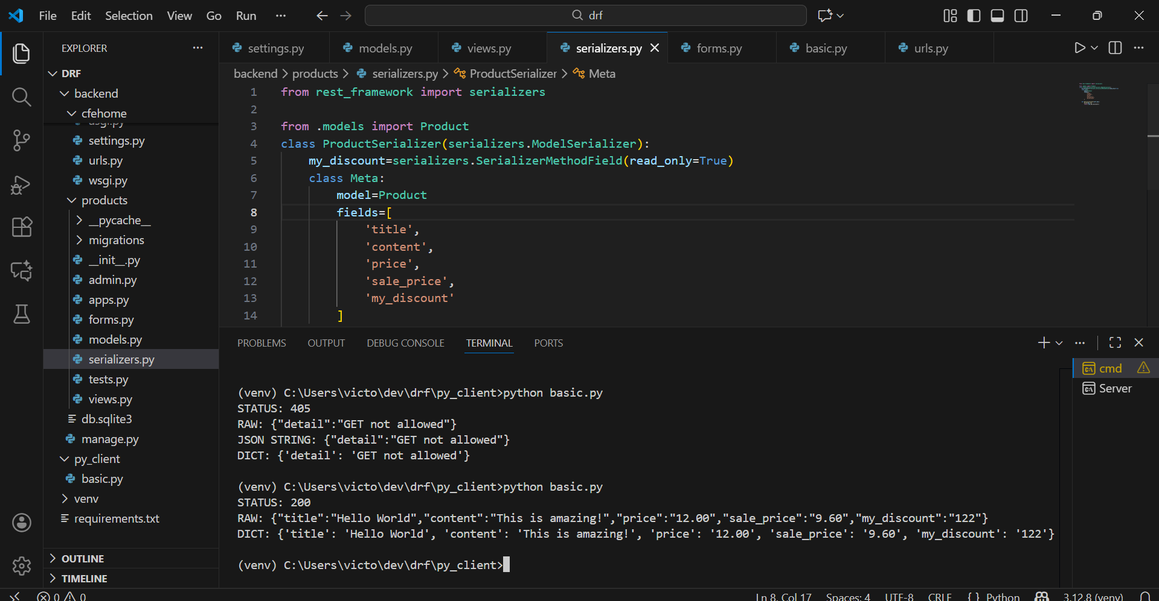
1. “Differentiating serializer fields vs model fields” — TRUE
Model fields
These are actual fields stored in the database, defined in models.py:
class Product(models.Model):
title = models.CharField(...)
price = models.DecimalField(...)
These fields exist in the database and Django creates columns for them.

Serializer fields
These are fields used to control what data is returned in the API, defined in serializers.py:
class ProductSerializer(serializers.ModelSerializer):
sale_price = serializers.CharField(read_only=True)
Serializer fields:
- Don’t necessarily exist in the database
- Are only used to format/prepare API responses
- You choose which fields to expose in your API

So yes, serializer fields are different from model fields.

2. “SerializerMethodField is used for custom or computed fields” — TRUE
✔ SerializerMethodField
Used when you want a field that is not stored in the database, but computed dynamically.
Example:
class ProductSerializer(serializers.ModelSerializer):
my_discount = serializers.SerializerMethodField()
This looks for a method:
def get_my_discount(self, obj):
return obj.get_discount()
What is this used for?
- computed values
- custom API-only values
- fields not in the database
- fields that need extra processing
- combining multiple model fields into one API field

So yes, SerializerMethodField is used ONLY for dynamic/custom/computed fields.

Final Confirmation
✔ Model fields = database columns
✔ Serializer fields = API fields (may include model fields + custom fields)
✔ SerializerMethodField = custom/calculated field included in API output
All your statements are correct.
If you want, I can show you a small table comparing:
- model fields
- serializer fields
- SerializerMethodField fields

RestFramework View and Response
GET Request Action:

Step 1 — The client sends a GET request
To:
/api/
Step 2 — DRF validates the request method
@api_view(["GET"]) ensures the view only accepts GET.
Any POST/PUT/DELETE would return “Method Not Allowed”.
Step 3 — You fetch data from the database
product = Product.objects.order_by("?").first()
This pulls a random product (or None if none exist).
Step 4 — You serialize the model
data = ProductSerializer(product).data
Serializers convert Django model objects → JSON-safe Python structures.
Step 5 — You return a proper DRF response
return Response(data)
DRF automatically:
- wraps the data
- applies content negotiation
- sets content-type to application/json
- handles encoding
5. What you successfully performed: Injecting data into an API response
In simpler terms:
✔ You pulled data from your Django model
✔ You encoded it using a serializer
✔ You returned it as JSON through a Django REST Framework API endpoint
This is the classic flow of any DRF backend.

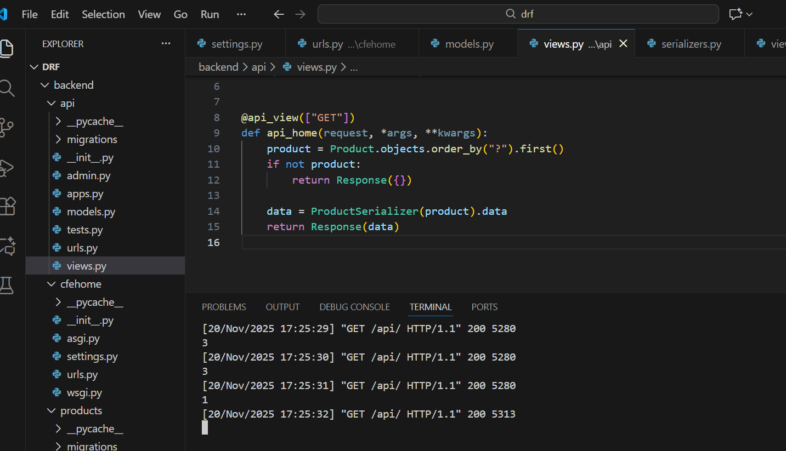

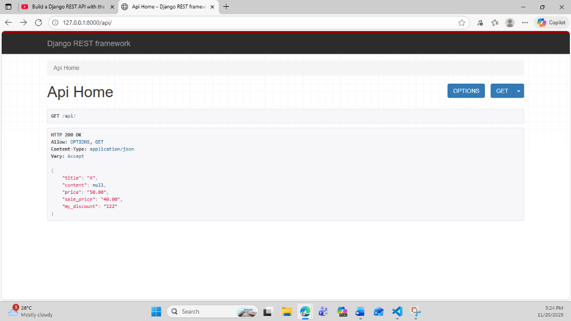
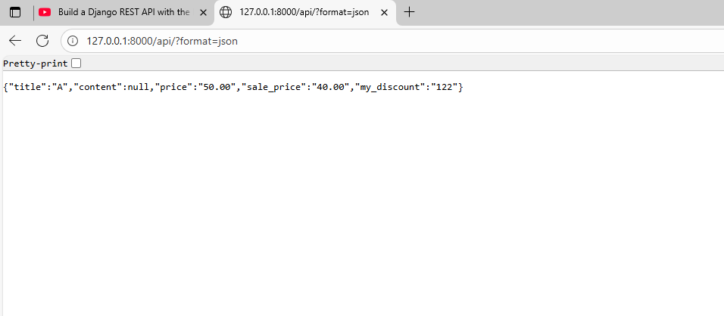
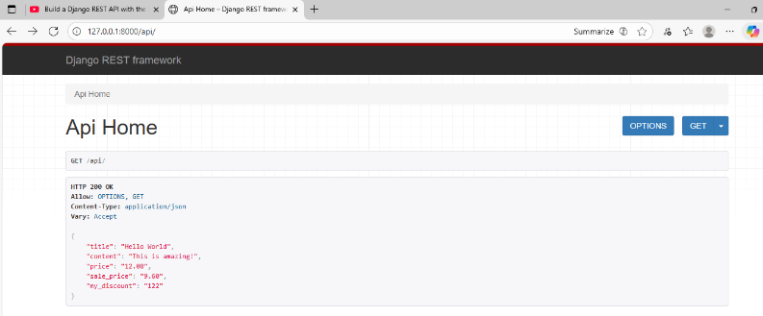

Last left at – 1:15:27

21/11/25
Injest Data with Django Rest Framework Views
2.POST Request
- Import requests
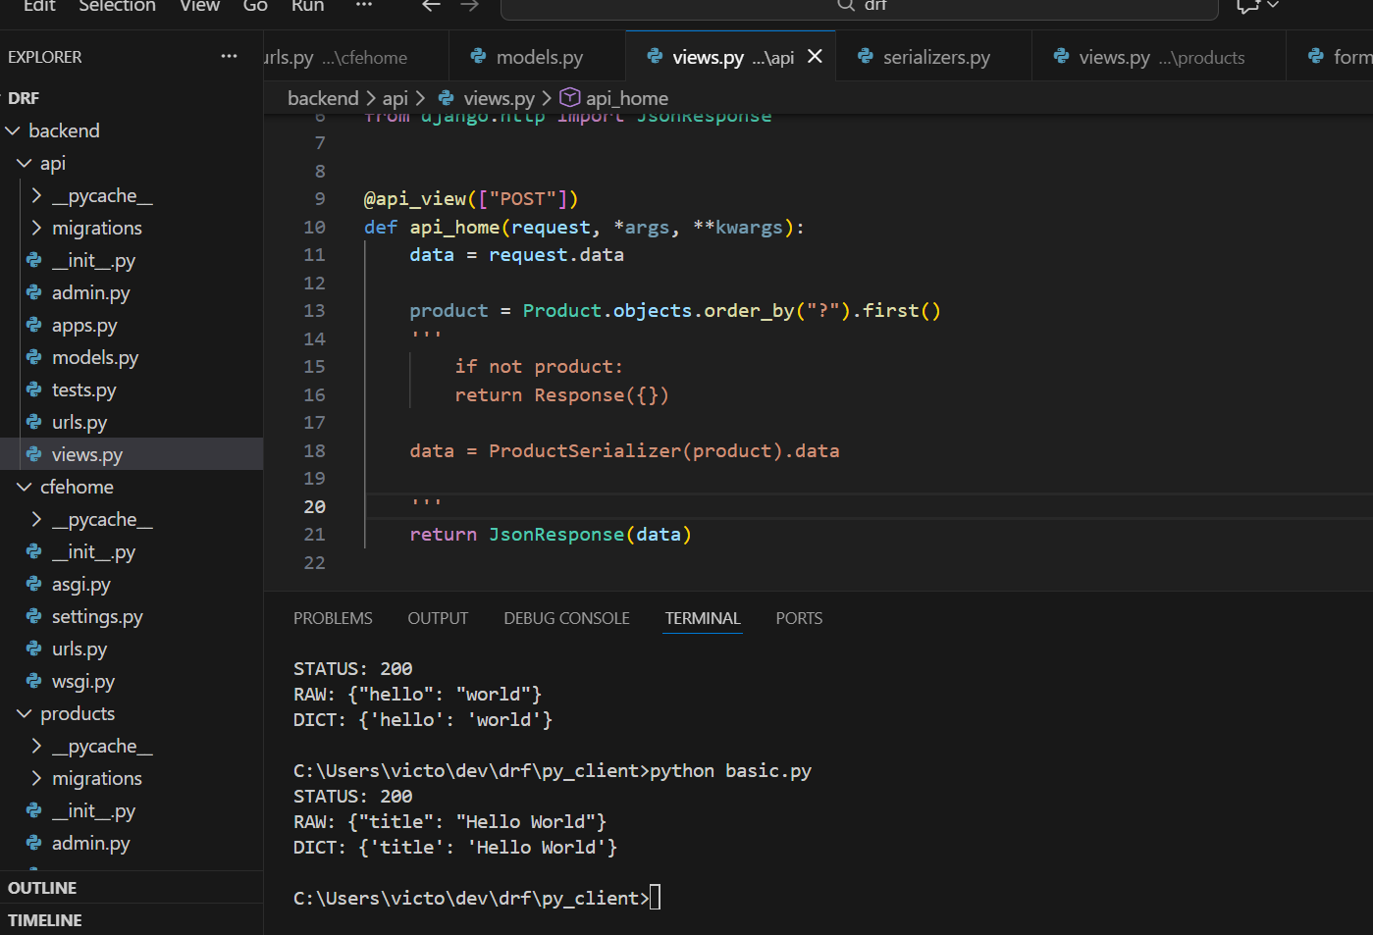
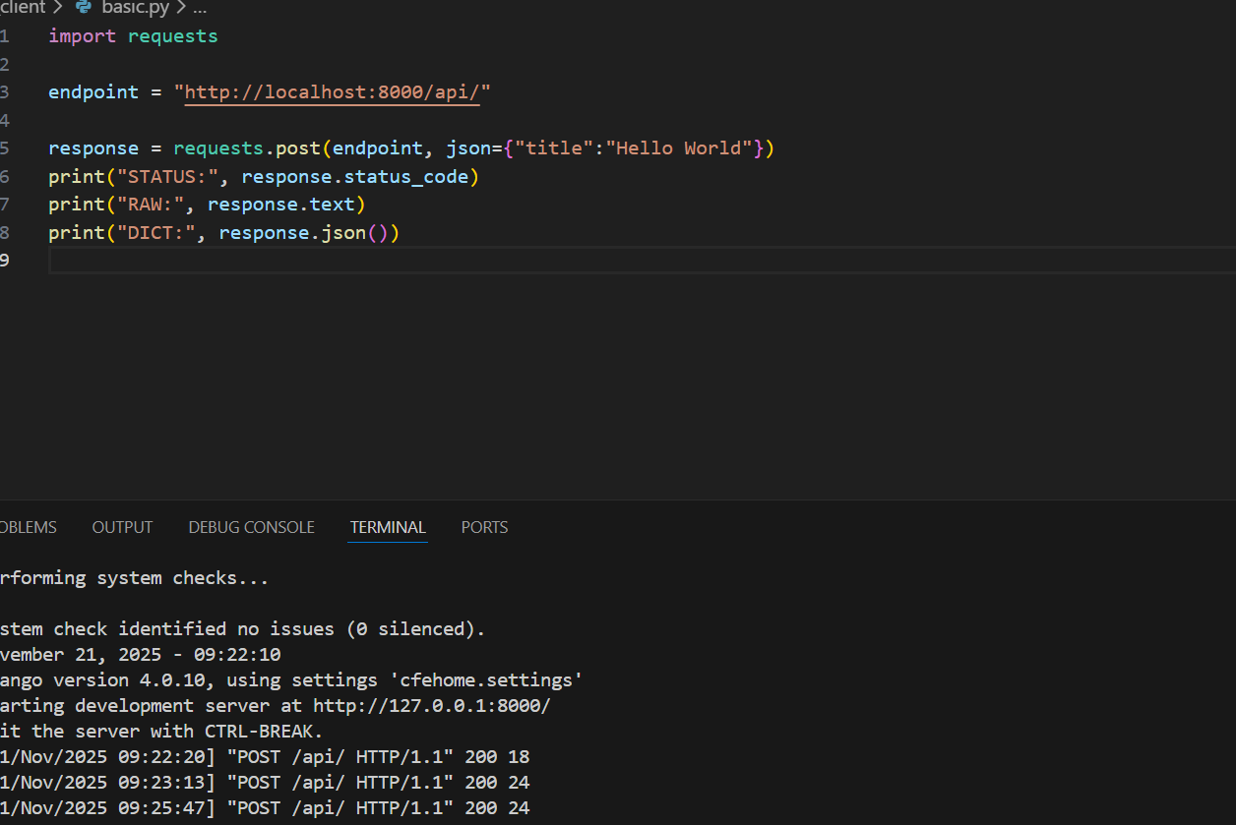

- Validate the data using serializers

Key Points
1. Incoming API data must match the serializer’s expected format.
The serializer validates every field and ensures the JSON structure and data types match what the model requires.

2. The serializer is built from the model, so model rules define what “valid data” means.
Field types, required fields, default values, and constraints all come from the model and are enforced by the serializer.

3. serializer.save() writes validated data to the database.
After validation, the serializer converts the cleaned Python data into a model instance and saves it as a row in the database.

4. After saving, the serializer instance represents a real model object.
Once saved, you can use model methods and properties because the serializer now holds an actual model instance.

5. The API response reflects the serializer’s output—not raw model data.
Whatever fields the serializer exposes (model fields, properties, method fields) will appear in the final JSON response.

6. The response JSON should consistently match the serializer’s schema.
The serializer defines exactly which fields appear in the API response and in what format, ensuring that the API output stays predictable.

Examples for the above:
Key Points With Mini-Examples (with my code)

1. Incoming API data must match the serializer’s expected format.
serializer = ProductSerializer(data=request.data)
If the client sends:
{"title": "Hello World"}
The serializer checks that "title" is valid for the Product model.

2. The serializer is built from the model, so model rules define what valid data is.
Your model:
class Product(models.Model):
title = models.CharField(max_length=120)
price = models.DecimalField(...)
Your serializer uses these model rules, so if a bad price comes in:
{"price": "ABC"} not a number
You get:
{"price": ["A valid number is required."]}

3. serializer.save() writes validated data to the database.
if serializer.is_valid():
product = serializer.save() # new DB row created
This converts the validated Python dictionary into a real Product instance stored in the database.

4. After saving, the serializer instance represents a real model object.
print(product.sale_price) # property on the model
print(product.get_discount()) # model method
These work only after .save() creates the model instance.

5. The API response reflects the serializer’s output—not raw model data.
return Response(serializer.data)
Serializer decides what fields appear in JSON, e.g.:
{
"title": "Hello World",
"content": null,
"price": "99.99",
"sale_price": "79.99",
"my_discount": "122"
}

6. The response JSON should match the serializer’s schema.
Whatever fields the serializer defines → become the response:
serializer = ProductSerializer(data=request.data)
return Response(serializer.data)
This guarantees the client always gets consistent, predictable output.

JSON vs Model Instance — Key Differences

1. JSON = External Data (From Client)
- Comes from the user, browser, or API client.
- Always text-based.
- Format example:
{"title": "Hello World", "price": "99.99"}
- Has no Python types, no methods, no logic.
- DRF converts it into a Python dict (request.data).

2. Model Instance = Internal Database Object
- A Python object created from your Django model.
- Represents a row in the database.
- Example:
product = Product(title="Hello World", price=99.99)
- Has:
  - Python types (Decimal, int, str)
  - Business logic
  - Methods (get_discount())
  - Properties (sale_price)
  - Saved or unsaved DB state

Short Summary Table
Concept | JSON | Model Instance
Origin | Client | Database
Format | Text (string-based) | Python object
Types | Strings only | Real types (Decimal, int, bool…)
Logic | None | Has methods & properties
Persistence | Not stored | Saved to DB table
Used by | API request/response | Application & ORM

How They Connect in DRF
JSON → Serializer → Model Instance
serializer = ProductSerializer(data=request.data)
serializer.is_valid()
product = serializer.save()
Model Instance → Serializer → JSON
serializer = ProductSerializer(product)
return Response(serializer.data)

DRF Generics
1.RetreiveAPIView
What is generics
Each model has a primary key by default
In Django, “generics” refers to Generic Class-Based Views (GCBVs) — built-in, reusable view classes that handle common patterns so you don’t have to write repetitive code.
Think of generics as pre-built view logic for the most common operations:
- Displaying a single object
- Displaying a list of objects
- Creating an object
- Updating an object
- Deleting an object
Instead of writing the same logic manually every time, Django gives you a generic class to inherit from.

Example: What generics replace
Without generics (function-based view)
You write everything yourself:
def product_detail_view(request, pk):
obj = Product.objects.get(pk=pk)
return render(request, "products/detail.html", {"object": obj})
You handle:
- database query
- template rendering
- context naming
- 404 handling

With generics
Each model has a primary key by default
Django gives you a built-in class that does all of this automatically.
from django.views.generic import DetailView
from .models import Product

class ProductDetailView(DetailView):
model = Product
template_name = "products/detail.html"
Django’s DetailView automatically:
✔ Fetches the object
✔ Returns 404 if not found
✔ Injects the object into context
✔ Uses <int:pk> from the URL automatically
That’s the power of generics.
Generics = prebuilt Django view classes for common CRUD operations.
They save us from writing repeated logic and reduce errors — especially the kind of mistakes you ran into today (URL patterns, detail fetching, missing error handling, etc.).

Example
Before (function-based view):
def product_detail_view(request, pk):
obj = Product.objects.get(pk=pk)
return JsonResponse({"title": obj.title})
After (generic view):
from django.views.generic import DetailView
from .models import Product

class ProductDetailView(DetailView):
model = Product
template_name = "products/detail.html"
- Django only loads URLs defined inside urlpatterns — any misspelling (like urlspatterns) breaks the entire routing system.
- Dynamic URLs must be written correctly:
Wrong
path('<int:pk/>', ...)
✔ Correct
path('<int:pk>/', ...)
- If Django fails to load URLs, the server does not start properly → the Python client receives WinError 10061 (connection refused).

If Found:
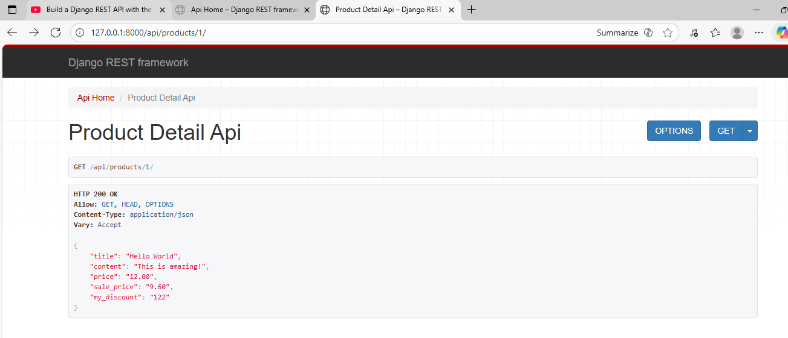
If not Found:
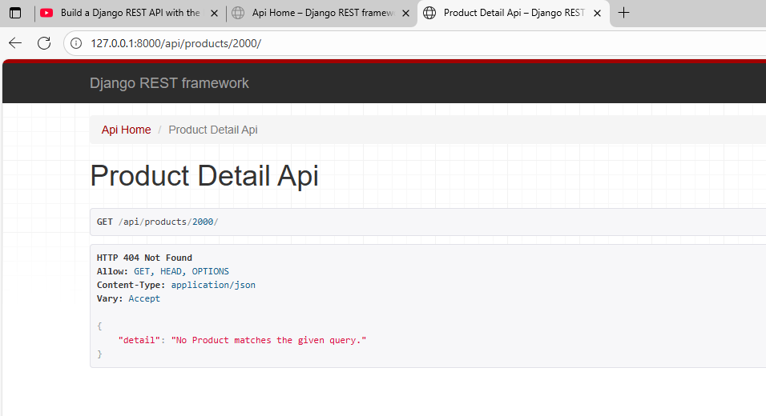

Backend
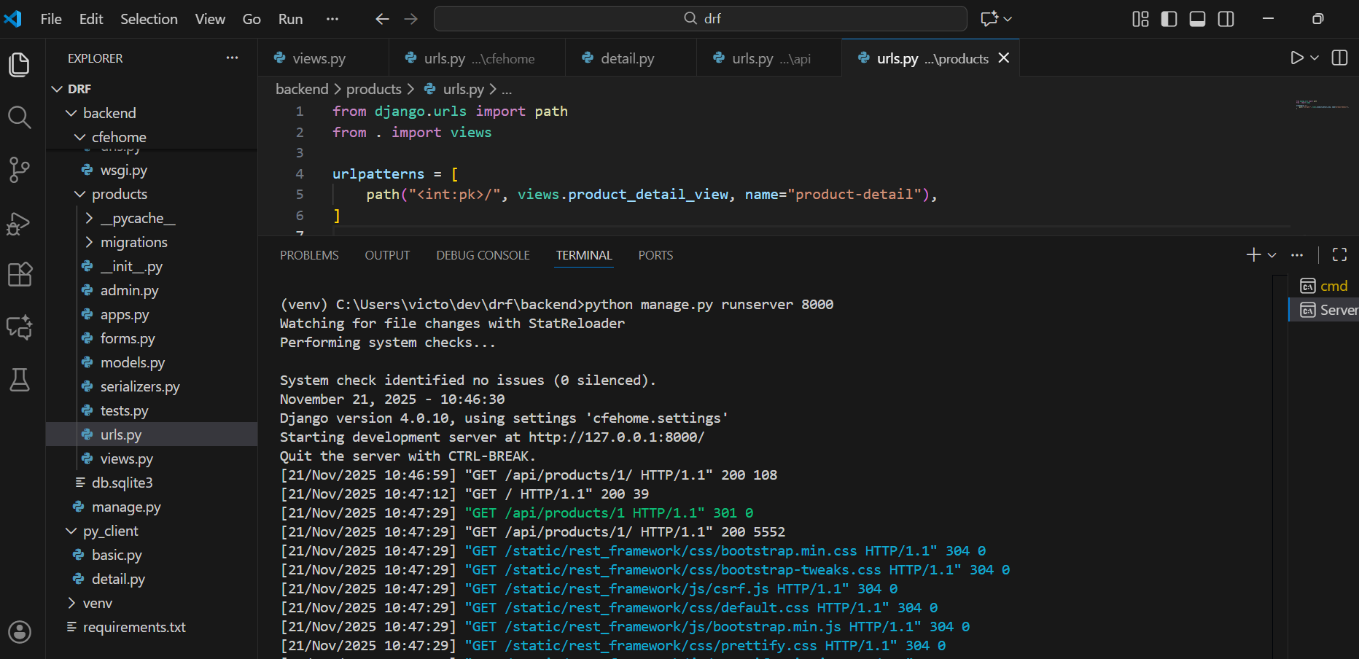
2. CreateAPIView
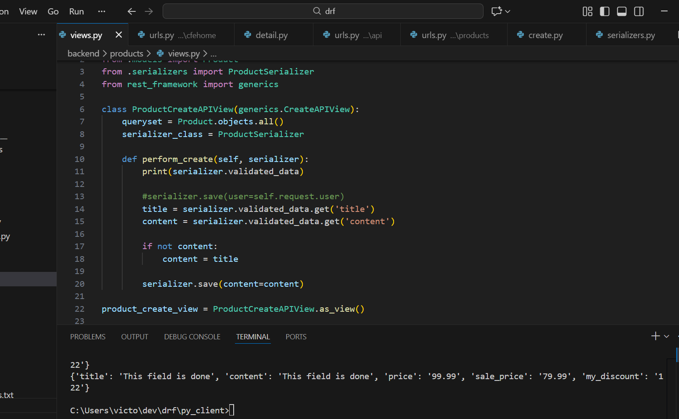

- CreateAPIView is a DRF view that handles POST requests.
- It takes user input → runs serializer → saves a new Product.
- perform_create() lets you customize what happens before saving.
- Here you check if content is empty → if yes, set it = title.
- serializer.save(content=content)
- RetrieveAPIView handles GET /<pk>/ - It fetches one product using primary key.

Hence this overall flow is:
This creates a product and fills missing content automatically using the title
After serializer validates input, DRF stores clean data in validated_data.
You force content to be saved with your custom value.

2. CreateListAPIView
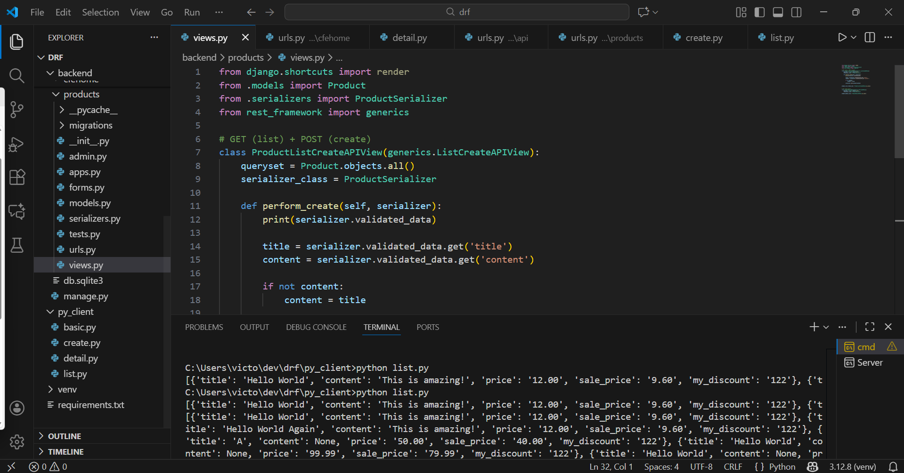
FLOW of ProductListCreateAPIView
1. Client sends a request to /api/products/
Two possibilities:

A) If the request is GET → List all products
- Django hits ProductListCreateAPIView
- DRF calls the internal list() method
- It fetches all products using the queryset
- Serializer converts queryset → JSON
- Response is sent back as a list
✔ Output: List of all products

B) If the request is POST → Create a new product
- Django hits ProductListCreateAPIView
- DRF validates the request using the serializer
- After validation, DRF calls the custom method:
perform_create()
Inside perform_create():
- We read the validated data
- If content is missing, we set content = title
- We save the new product
- DRF returns the created product as JSON
✔ Output: Newly created product with auto-filled content

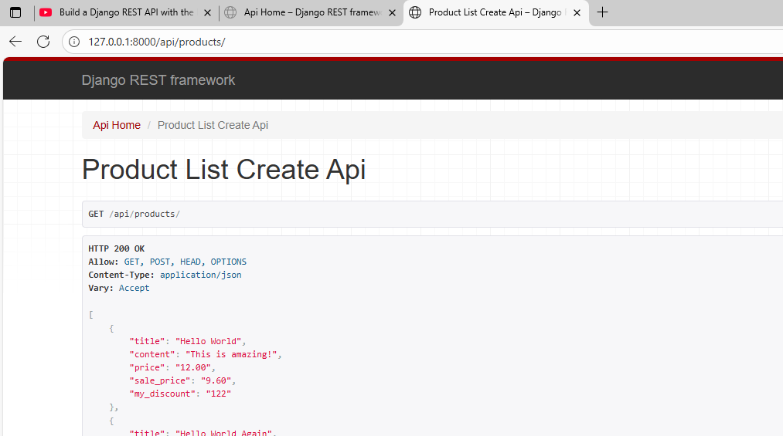
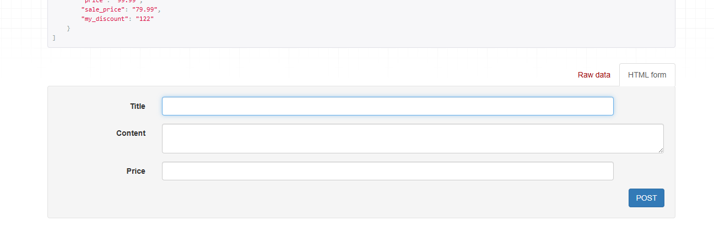
Tried Posting:
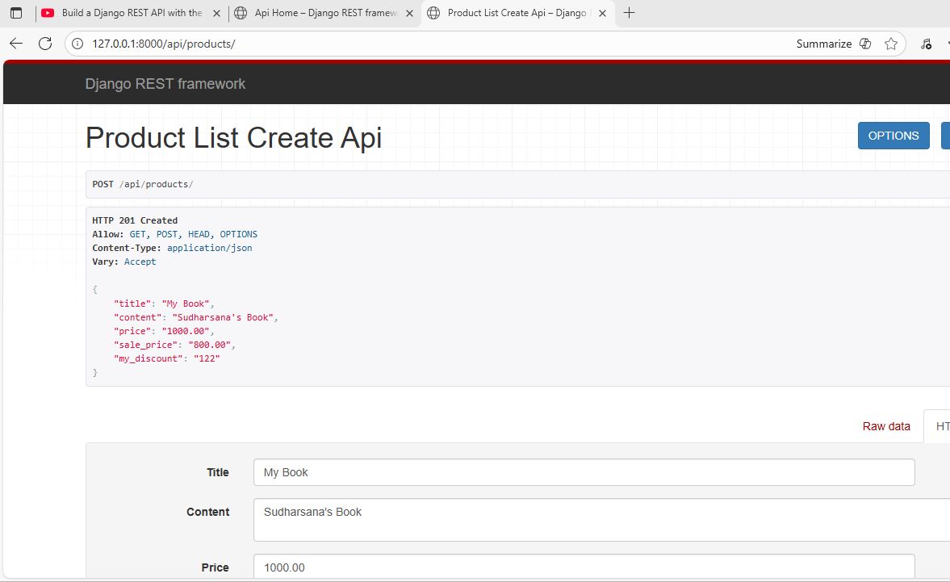
Retrieved the same using the id [9]
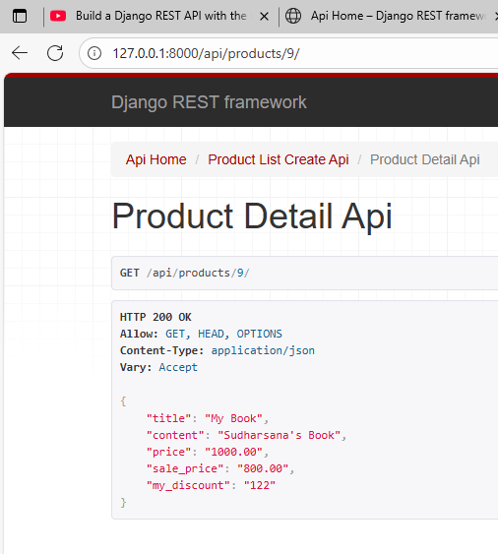

Using Function Based views for create retrieve or List
Function-Based Views (FBVs) are Django views written using regular Python functions instead of classes.
They handle HTTP methods like GET and POST manually inside the function.

UpdateAPIView and DestroyAPI Views

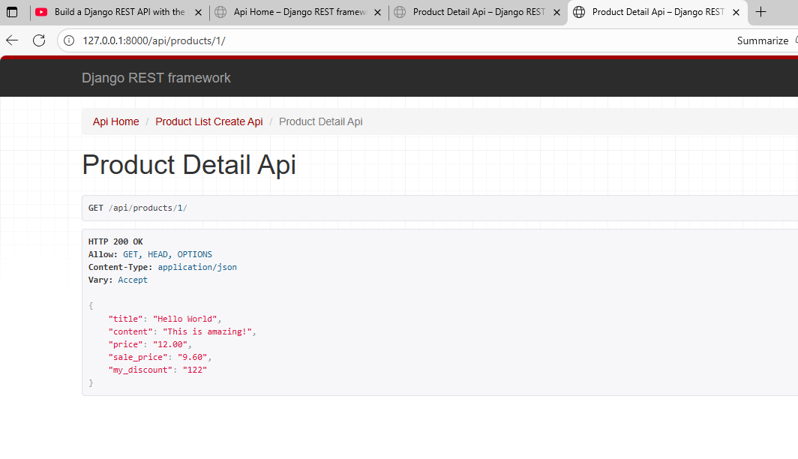

UpdateAPIView = only PUT + PATCH
If we want in UI then use Retrieve
can make the update URL also work with GET, but not with UpdateAPIView alone.
But if you want:
✔ GET (show existing data before update)
✔ PUT/PATCH (update data)

Then you must use:
RetrieveUpdateAPIView
This class supports:
- GET → retrieve one item
- PUT → full update
- PATCH → partial update
Update
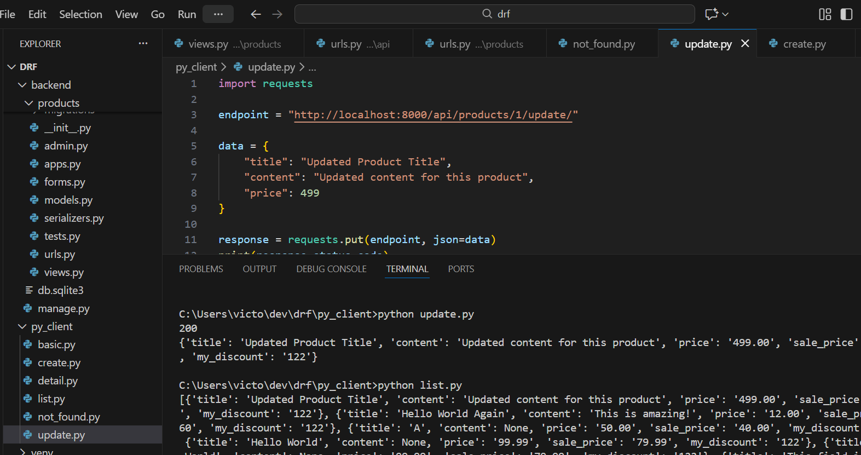
Delete
Before deletion
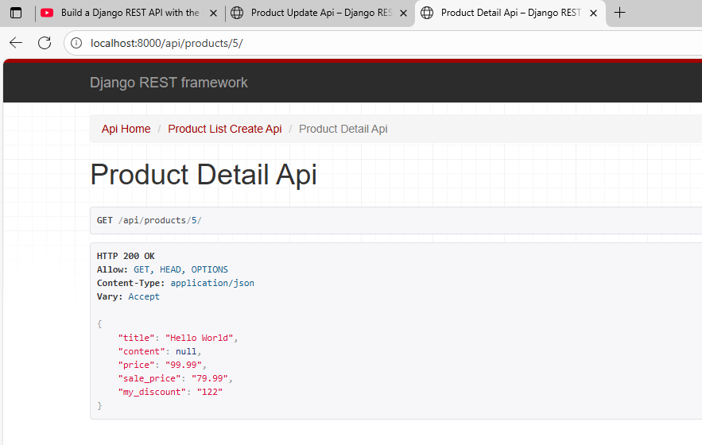
After deletion
204 is perfect — it means DELETE successful
According to REST standards:
- 200 → deleted + returns data
- 204 → deleted + returns nothing
- 404 → object not found

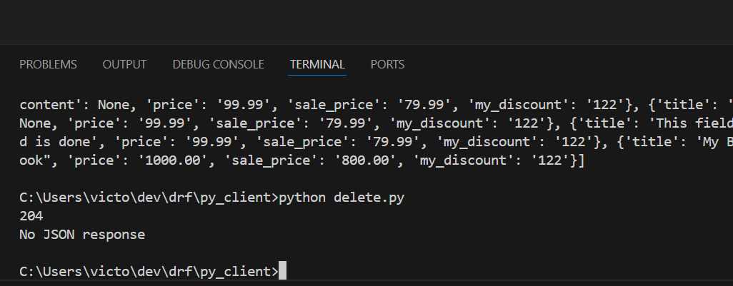
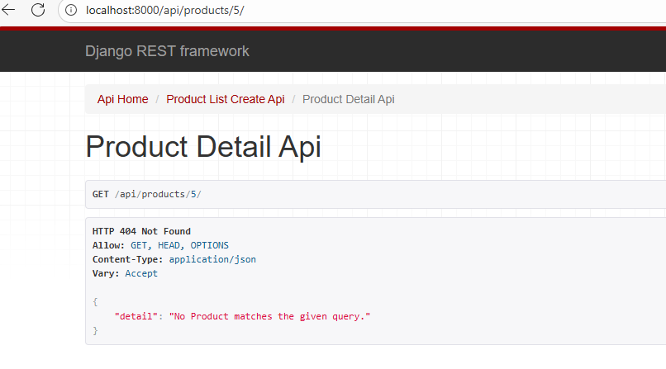

Mixins and Generic API
If we already have ListAPIView…
Why do we still need ListModelMixin?
Because ListAPIView itself is built using ListModelMixin.
DRF structure works like this:
ListModelMixin → gives "list" functionality
GenericAPIView → gives queryset + serializer features
ListAPIView → combines both into one ready-made view
So:
✔ Mixins = low-level building blocks
✔ Generic views = high-level shortcuts built using mixins

⭐ Why keep mixins separately? (Main Reason)
So you can customize and combine features however you want.
Example:
What if you want:
- GET single product (Retrieve)
- POST create product (Create)
There is no built-in view in DRF that does this combination.
But you can create it using mixins:
class MyCustomView(
RetrieveModelMixin,
CreateModelMixin,
GenericAPIView
):
queryset = Product.objects.all()
serializer_class = ProductSerializer
This is why mixins exist → flexibility.

⭐ Why use ListAPIView then?
Because for common use cases, DRF gives shortcuts.
Example:
class ProductListView(ListAPIView):
queryset = Product.objects.all()
serializer_class = ProductSerializer
No need to write:
- ListModelMixin
- GenericAPIView
- custom get() method
✔ Less code
✔ Clean
✔ Faster development

⭐ Very Simple Conclusion:
Situation | What to use
You want normal list view | ListAPIView
You want list + create in ONE endpoint | ListCreateAPIView
You want custom combinations | Mixins + GenericAPIView

🎉 One-line answer:
We have ListAPIView for convenience,
but we keep ListModelMixin for flexibility.

If you want, I can show you:
- Function-based view version
- Mixin version
- Generic view version
all for the same API, so you understand the difference 100% clearly.
1.Create a super user
For Django Administration
sudharsana
root
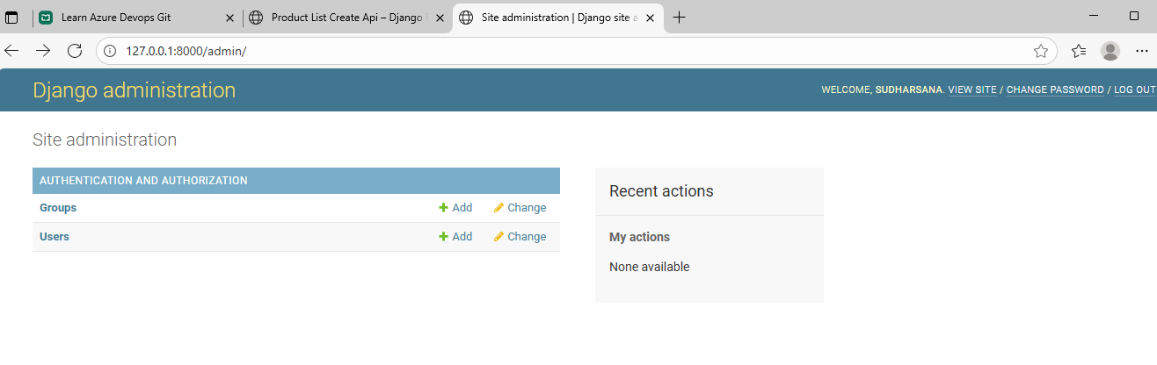
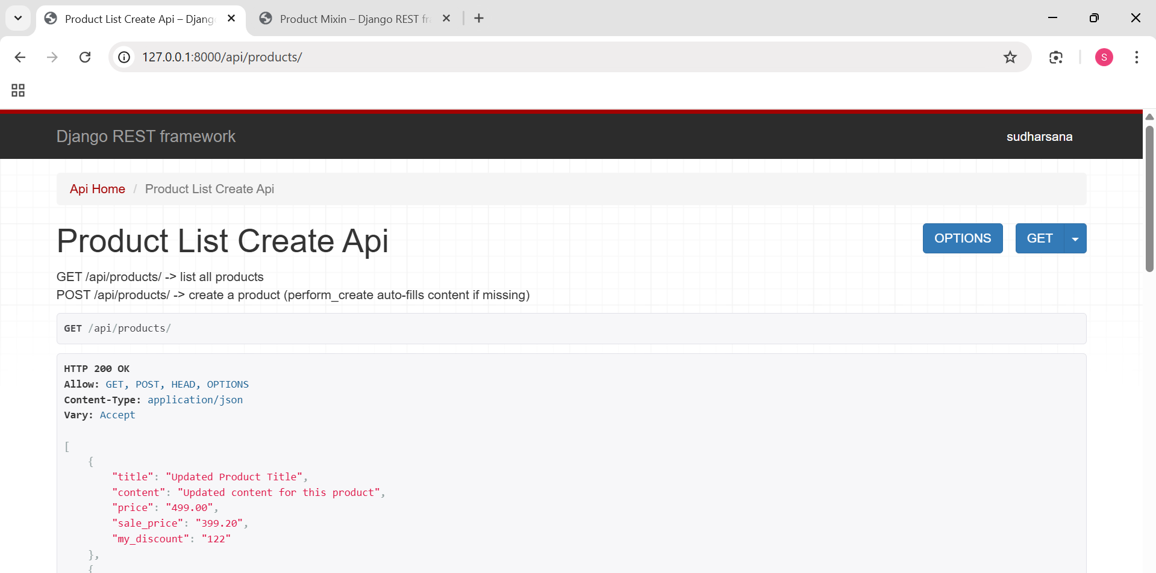
2. RetrieveModelMixin (GET /<pk>/)
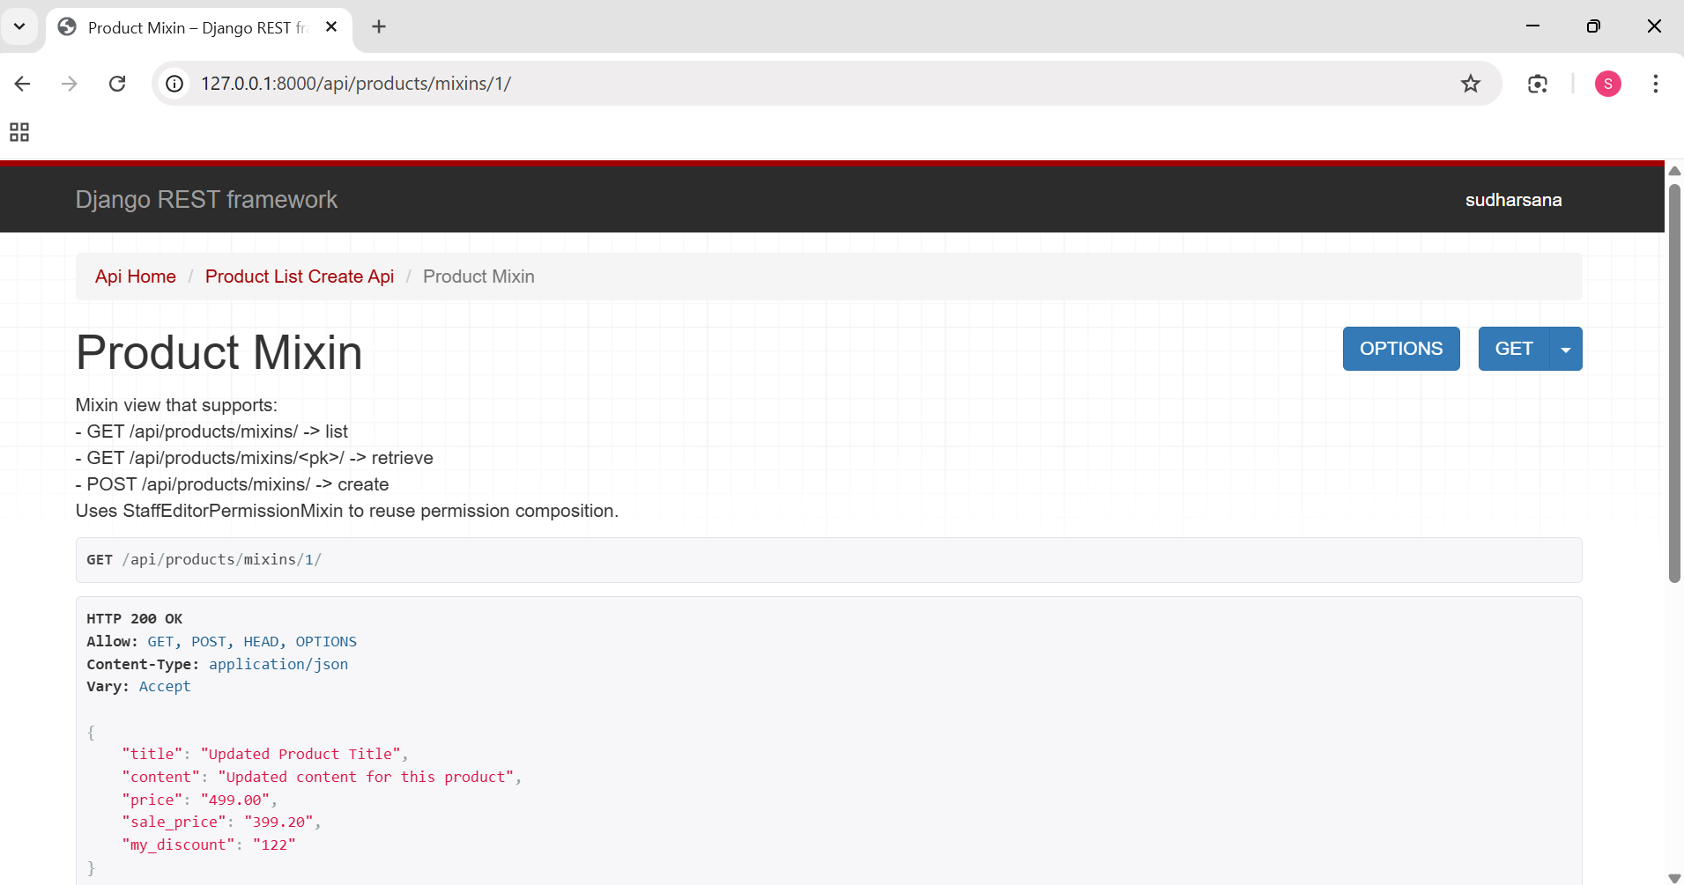
Step 3: CreateModelMixin (POST /api/products/mixins/)
Goal: Create a new product using the mixin view.
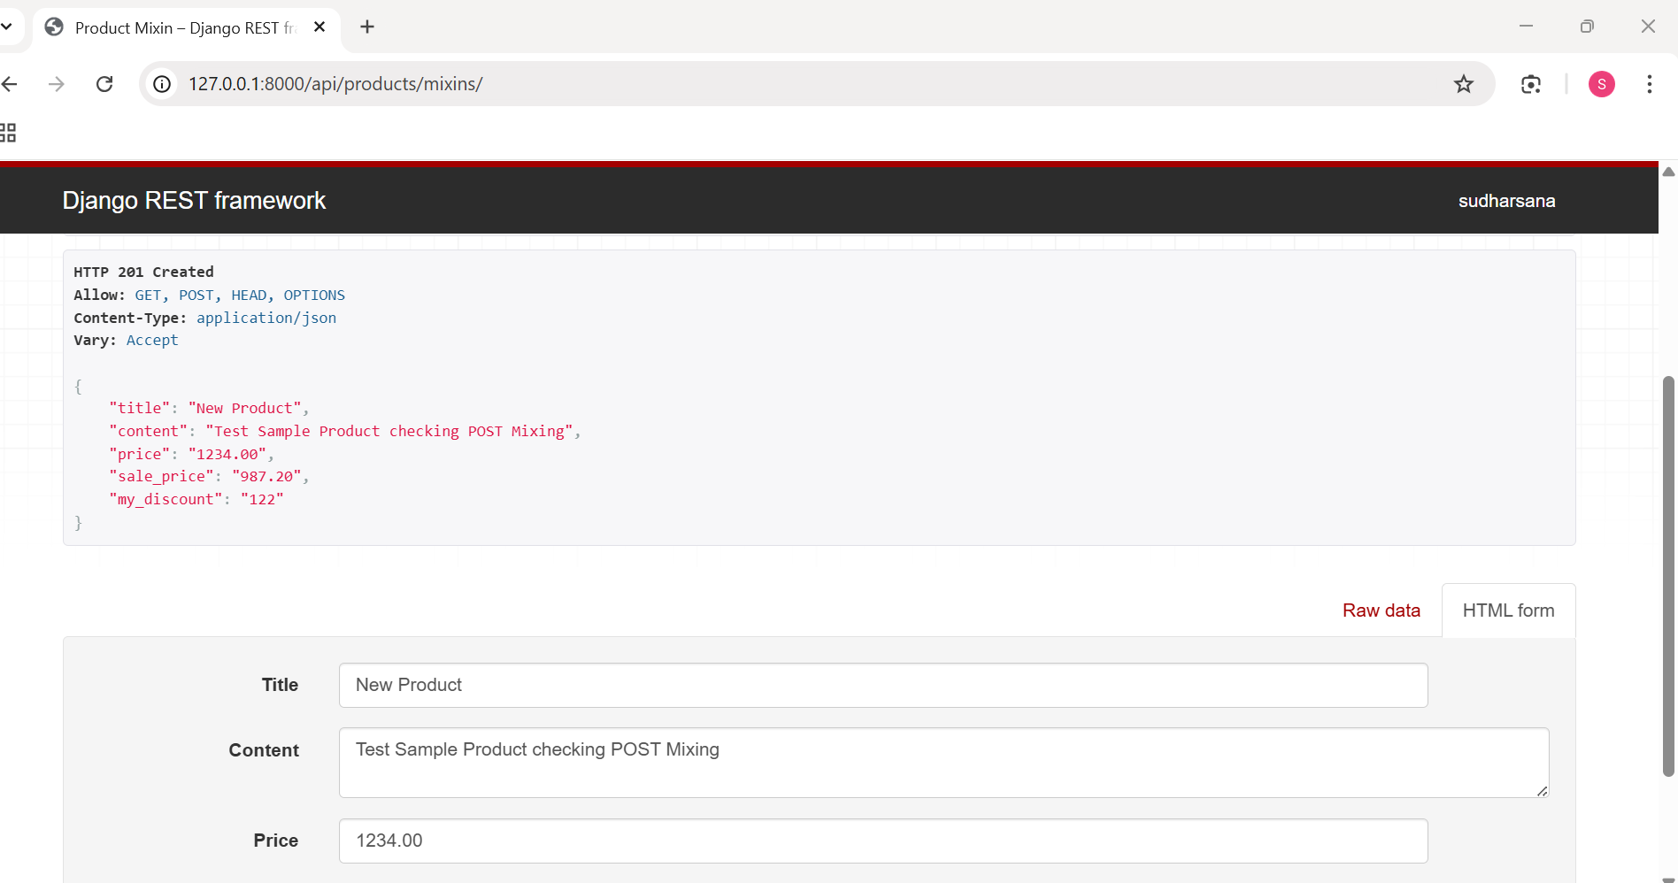

4.Update the created product (PUT)
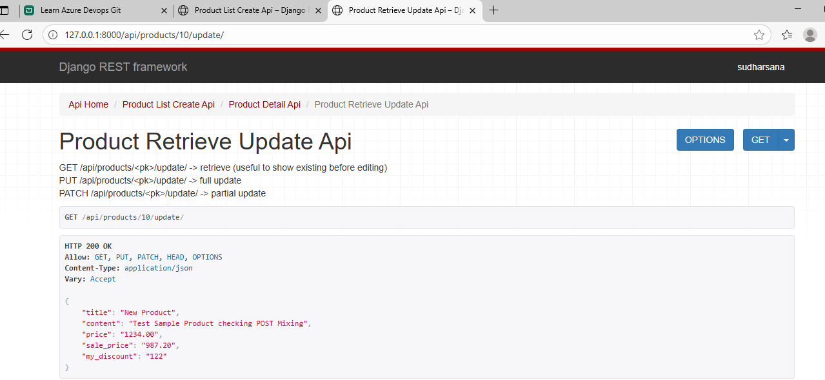
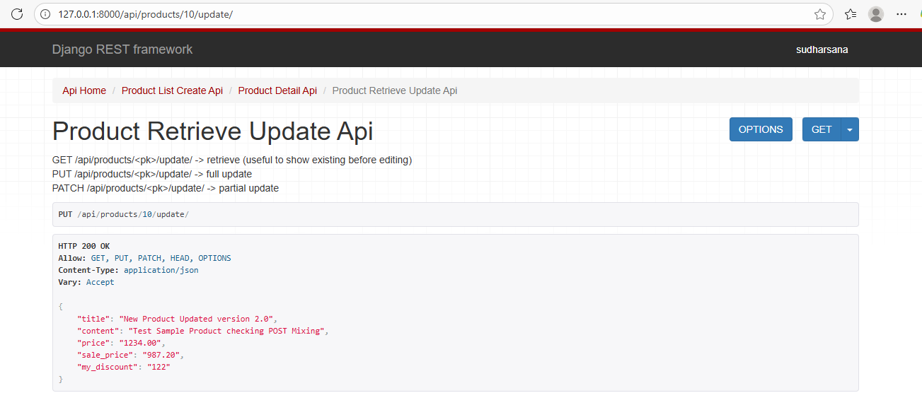
5.Deletion
For deletion it is only put+patch and nit get
hence u cant see in browser
so u can only run python script
but even there user should be authenticated
Because browser uses session and raw script not
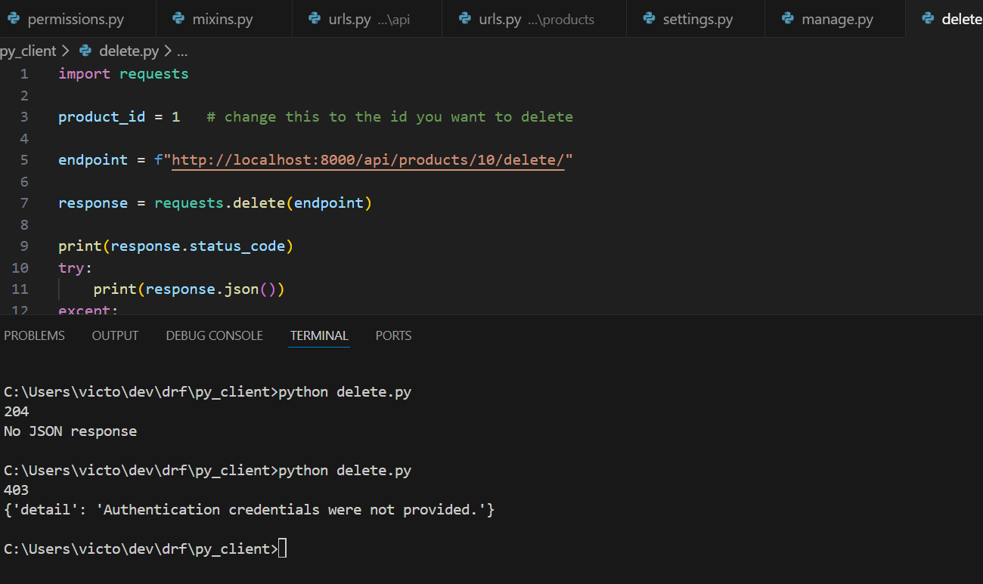

After giving superuser name and password I can delete
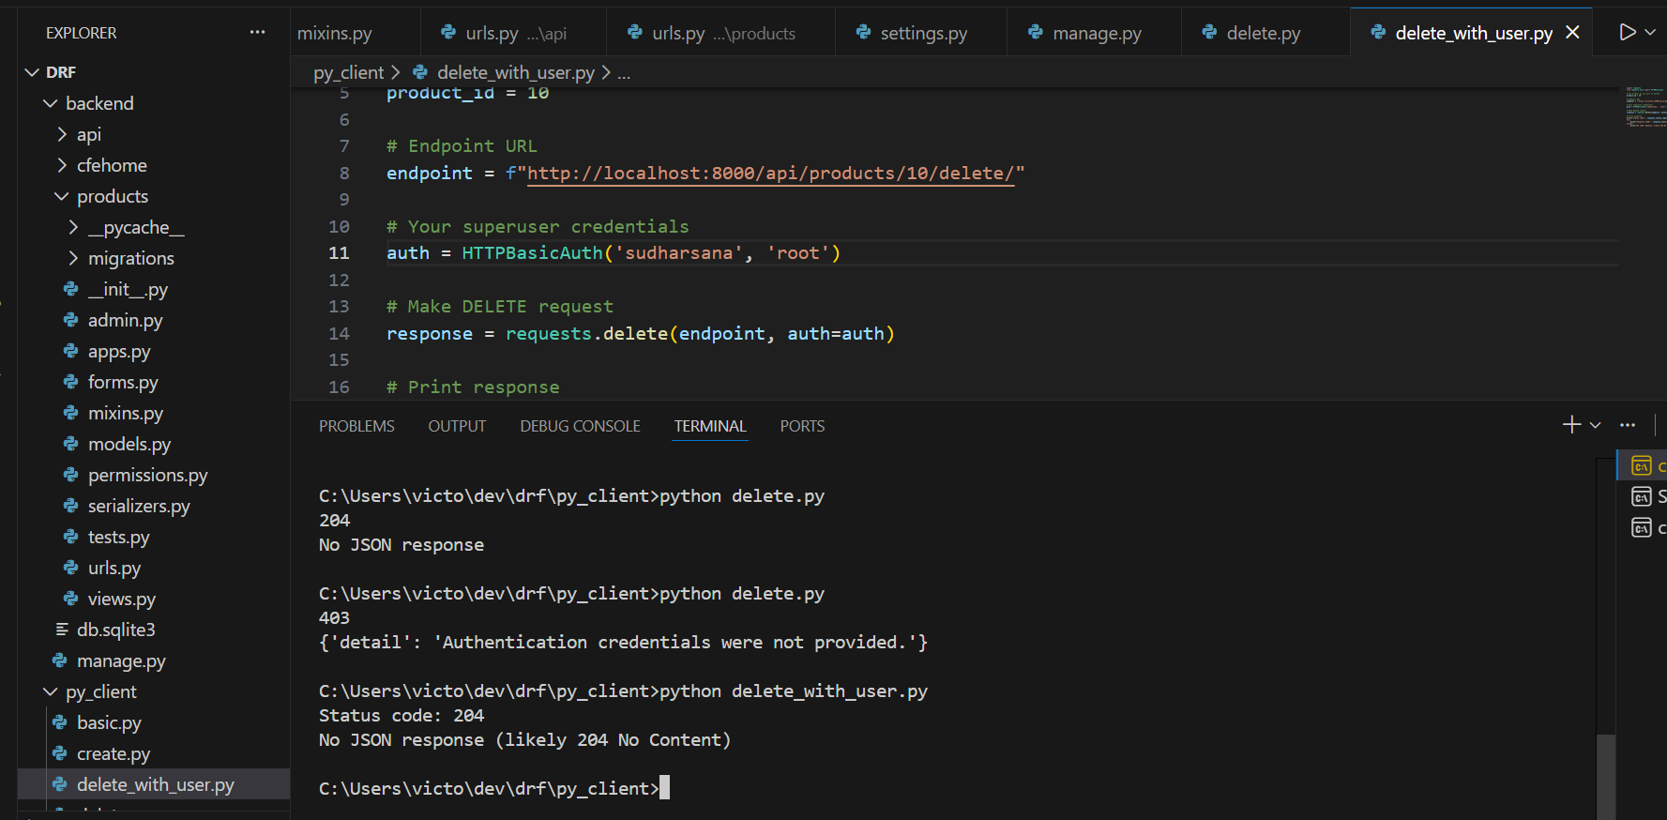

Creating Staff user:
Username:sri
password: sriroot2608
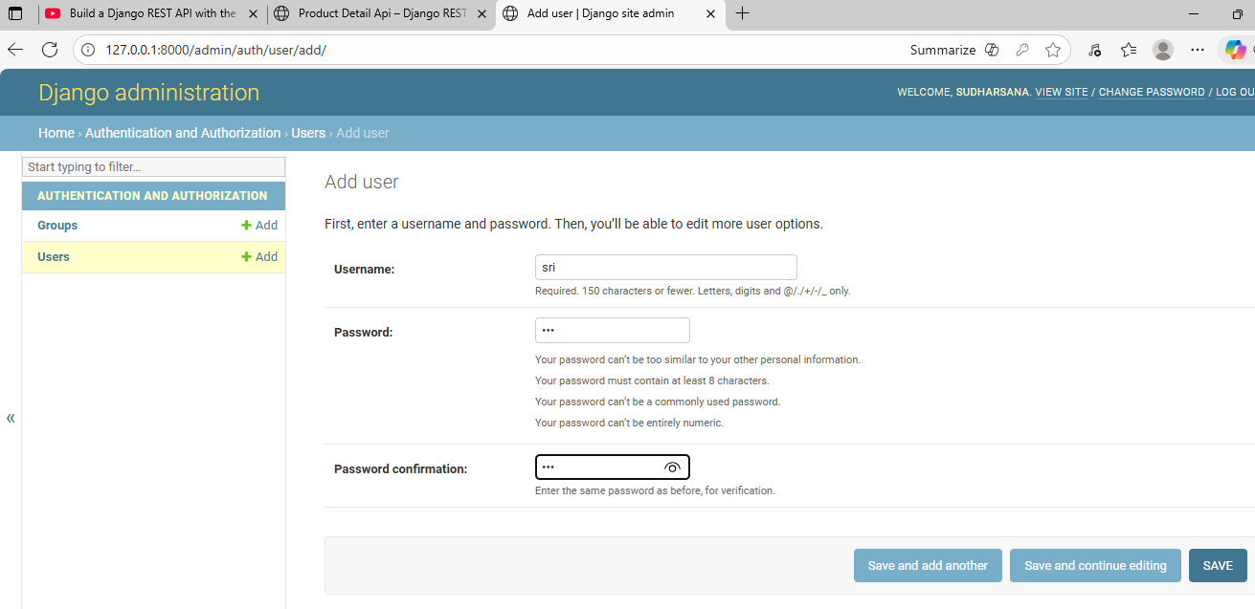
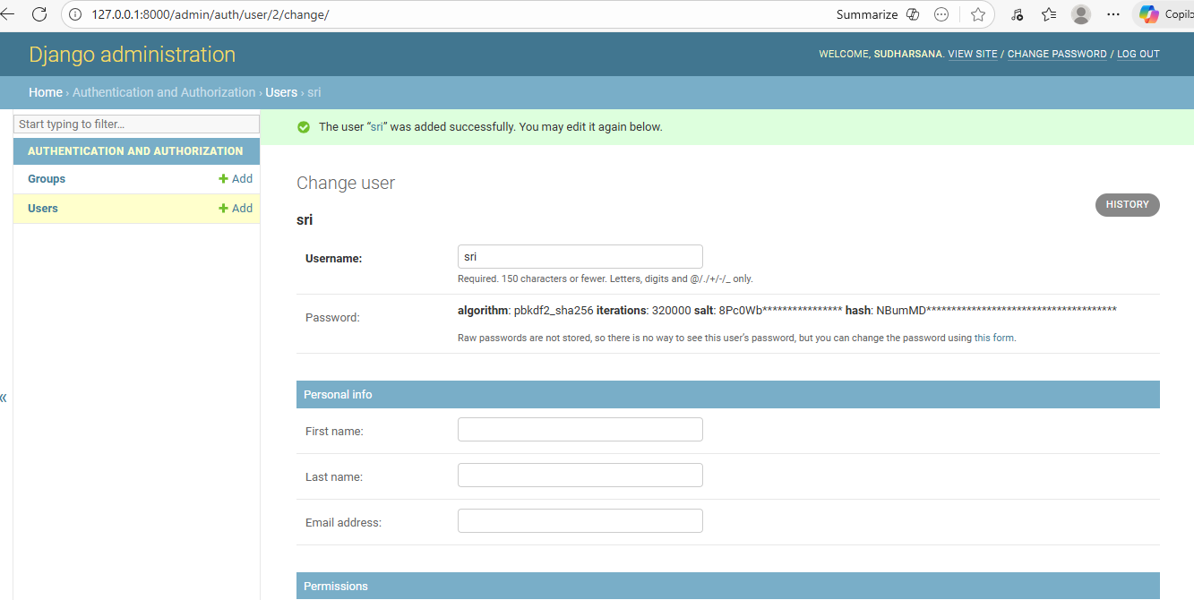

Set status
Error
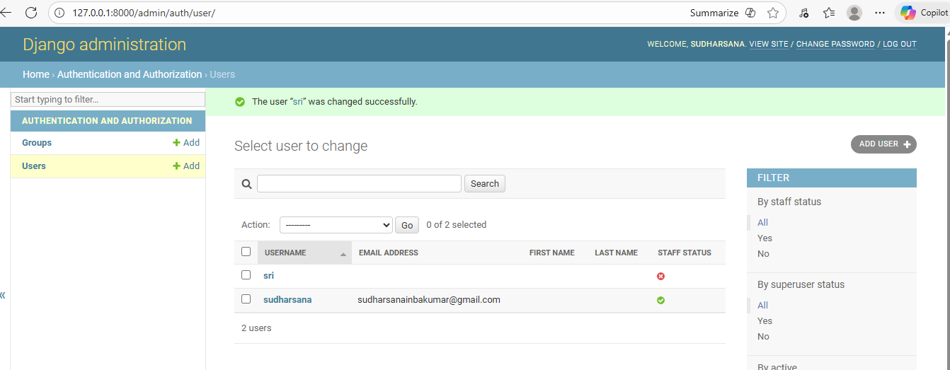
To avoid this:
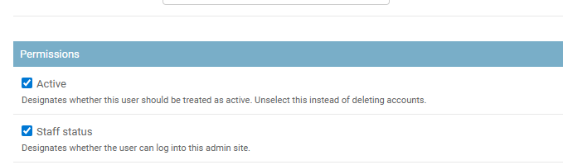
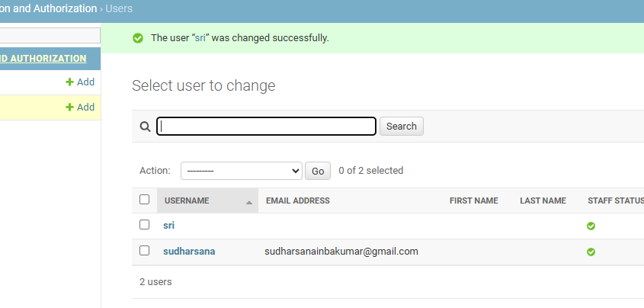

Give permission to staff user
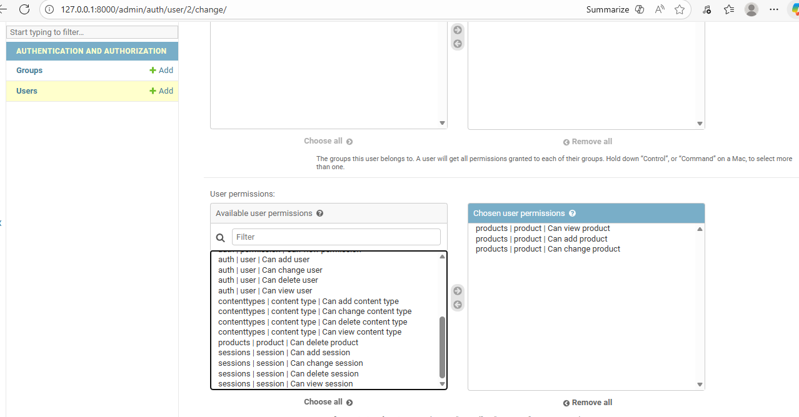

Now sri can
Add
update acc to the permissions set by super user
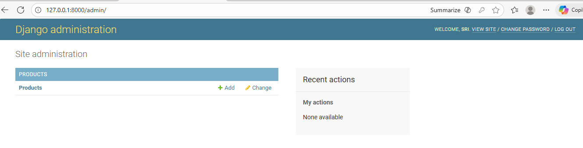
Output:
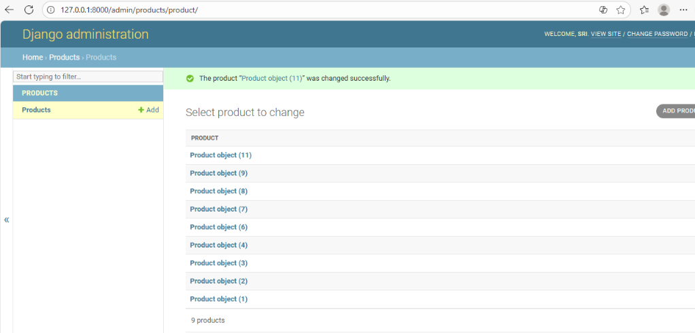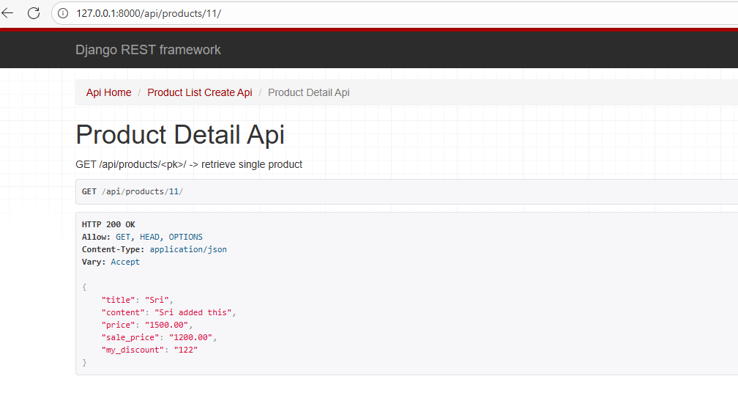
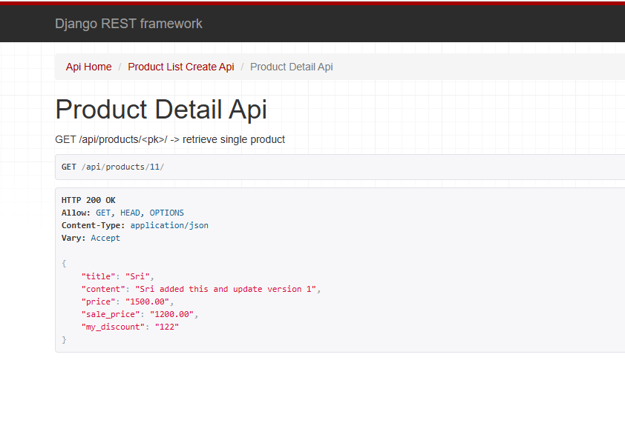

22/11/2025
User and Group Permissions
Step 1: Create Groups in Django Admin
- Open Django Admin: http://127.0.0.1:8000/admin/
- Go to Groups → Add
- Create a group, e.g., ProductEditors
- Assign permissions to the group:
  - view_product
  - add_product
- Save the group.
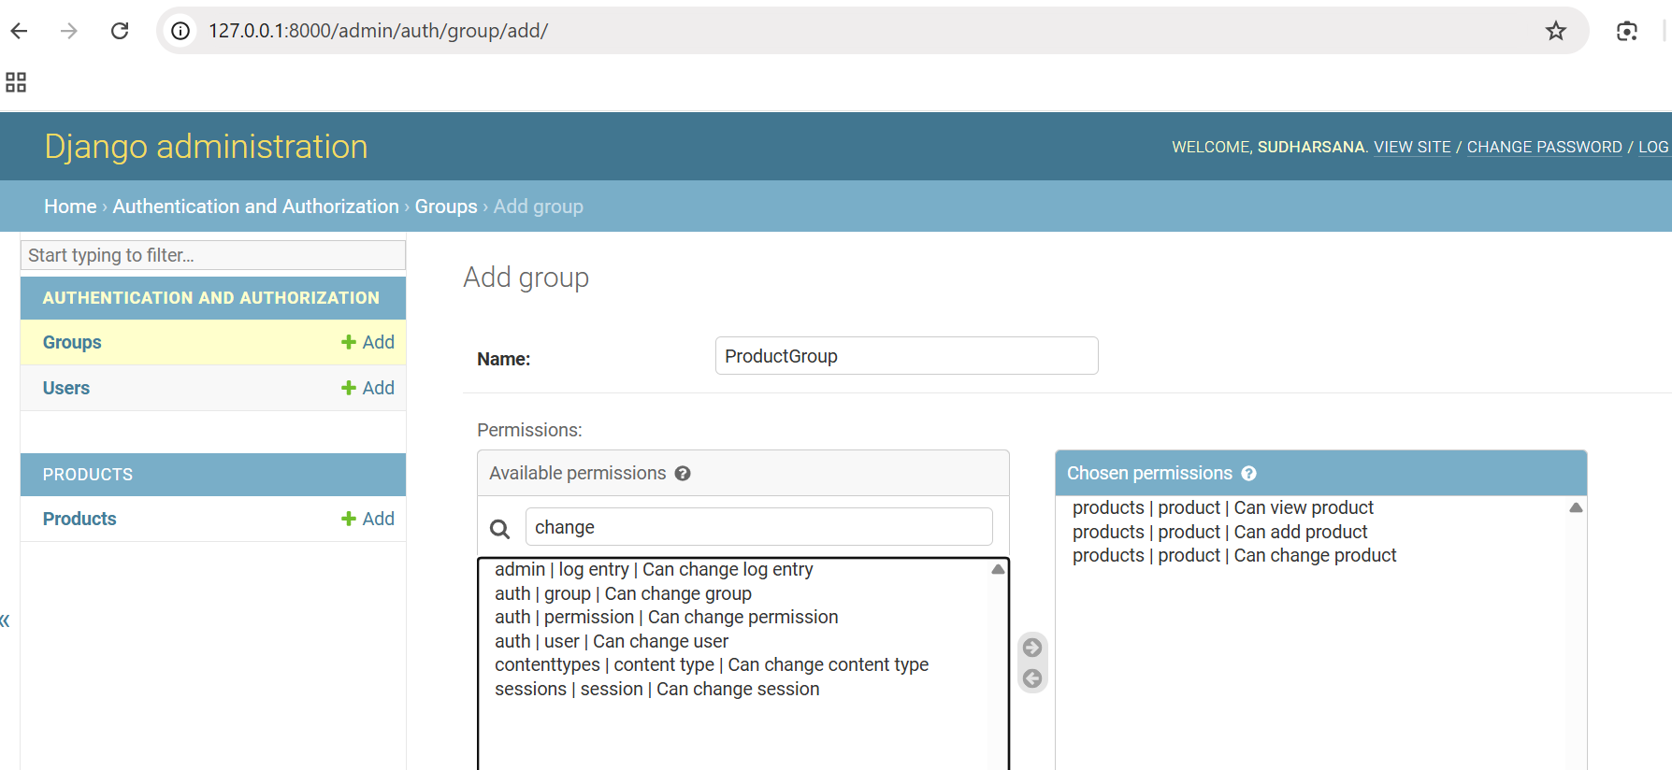

Step 2: Assign Users to Groups
- Go to Users → Your staff user (e.g., sri) → Groups
- Select the group you just created (ProductEditors)
- Save the user.

Here I have added two staff users
sri – add/view/change
Inba – add/view
Product group – add/view

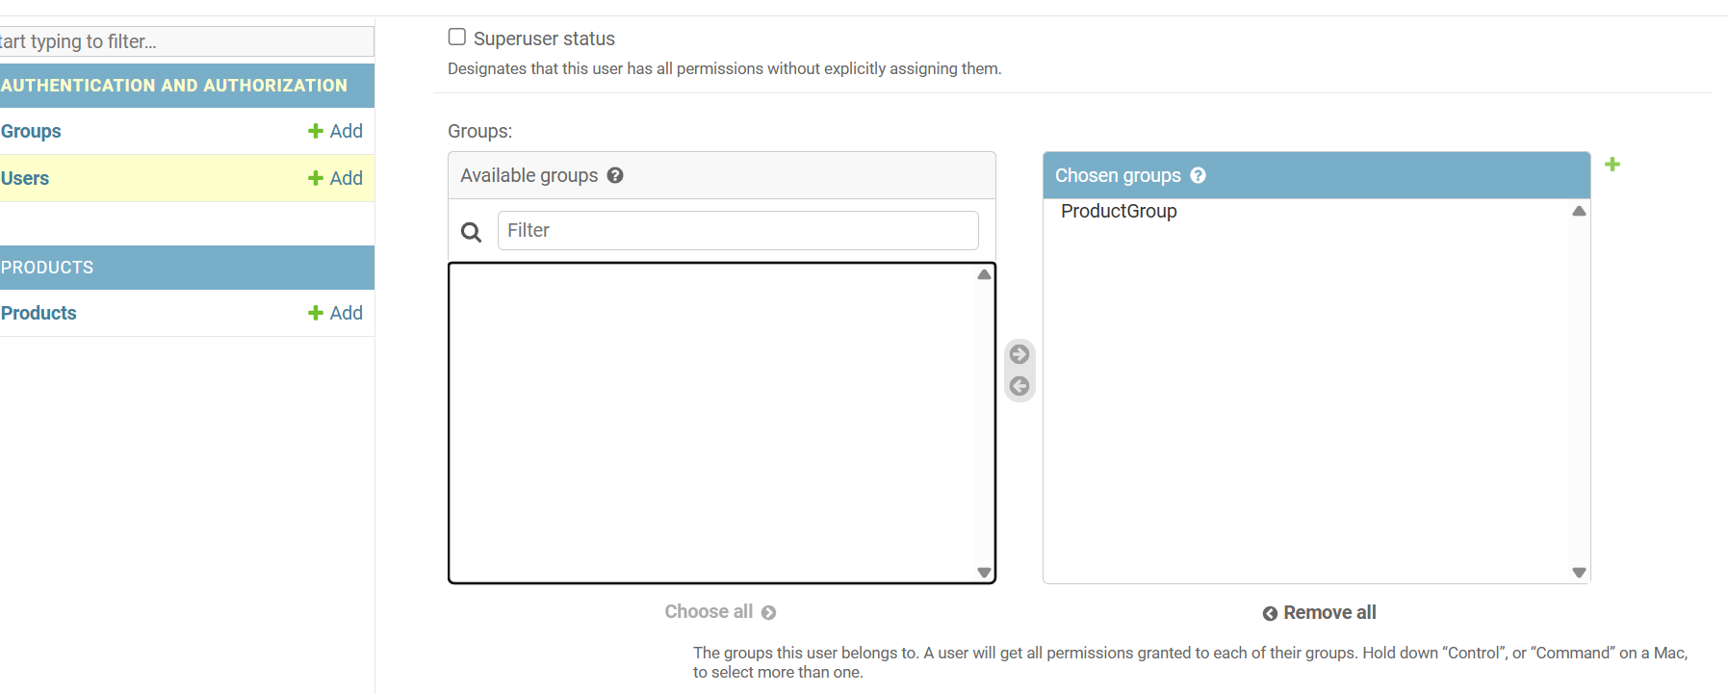
Granularity of Django permissions vs. groups
How Django Permissions Work
- Every user can have:
  - Individual permissions (directly assigned in their user profile).
Example: products.change_product
  - Group permissions (user inherits all permissions from groups they belong to).
Example: Group ProductGroup has view_product and add_product.
Here sri and inba can view and add_product but
Only sri can update the product
Superusers automatically bypass all checks — they have all permissions.

Scenario Setup
Group: ProductGroup
- Permissions assigned:
  - view_product → user can see/list products
  - add_product → user can create products
- No change_product → user cannot update via API unless individually assigned
User: testuser
- Belongs to ProductGroup
- Individual permissions (optional):
  - change_product → user can now update products
  - delete_product → user can delete products (if needed)

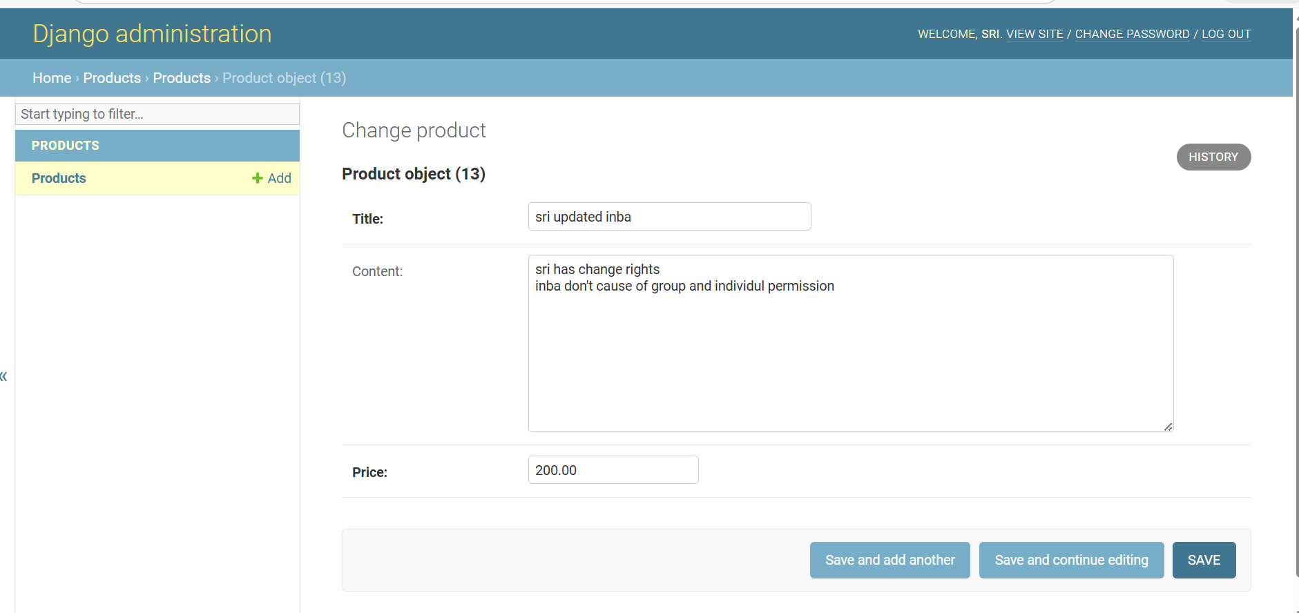
For Inba :
Only Add and View
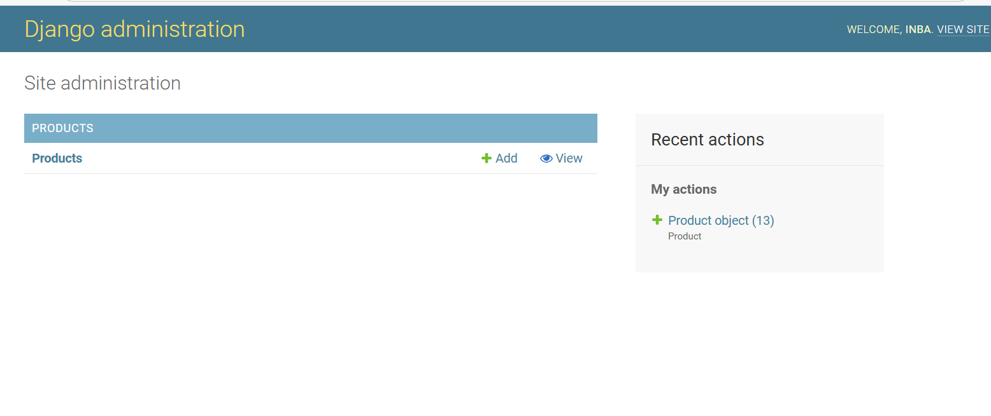
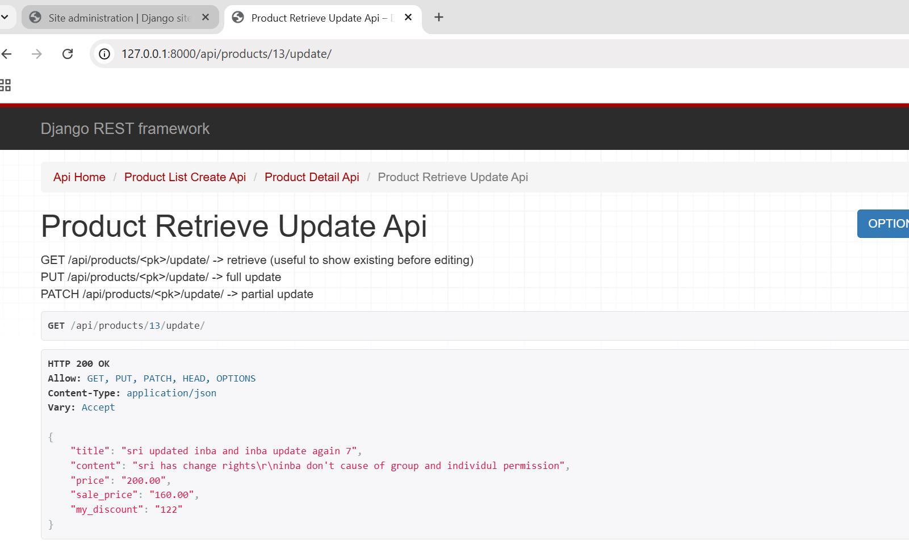
You cant see the option to update
The important key note in the code:
Added
Problem 1:
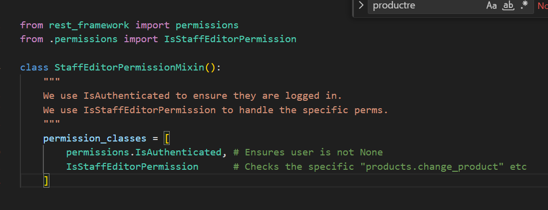

Problem 2:
The "Left-to-Right" Rule (MRO)
Method Resolution Order
The Result: Python found the default permissions inside RetrieveUpdateAPIView first (which usually allow any logged-in user). It stopped looking there and never even saw your StaffEditorPermissionMixin on the right side.
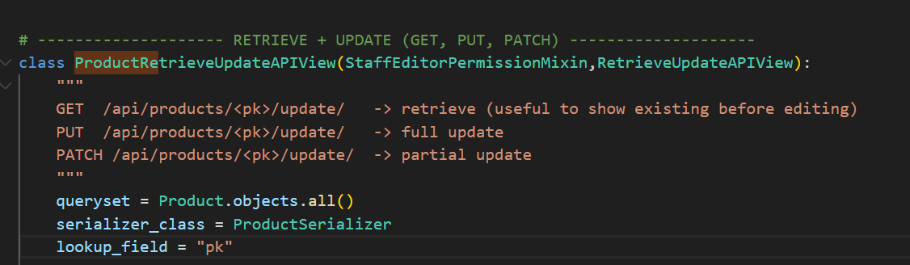
Problem 3:
IsAdminUser means "Superuser." In Django, it actually means "Anyone with is_staff=True".
The Result: Since inba is a staff member, IsAdminUser returned True. Because you used the OR (|) operator, Django said, "One of these is true, so let him in!" It completely skipped your custom code that checks for specific permissions like change_product.
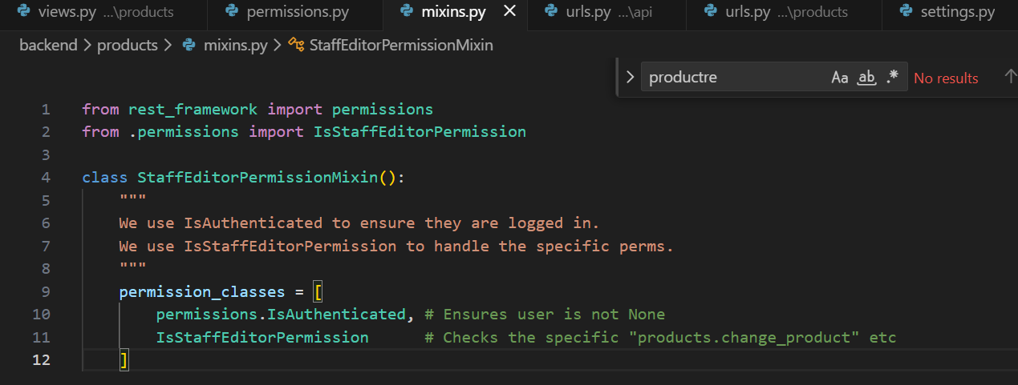

Token Authetication
Token generation:
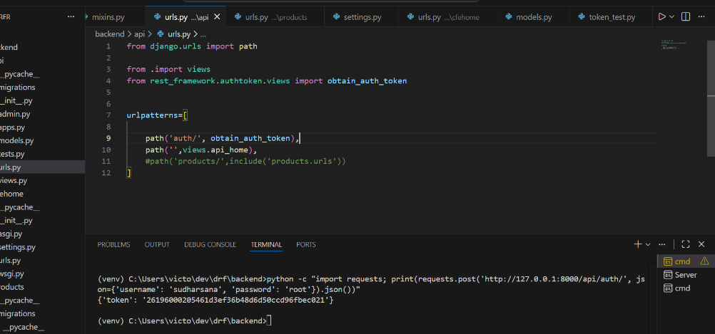
Fully interactive console commands to verify the access levels to each user via token
Here sri ->create/view/update
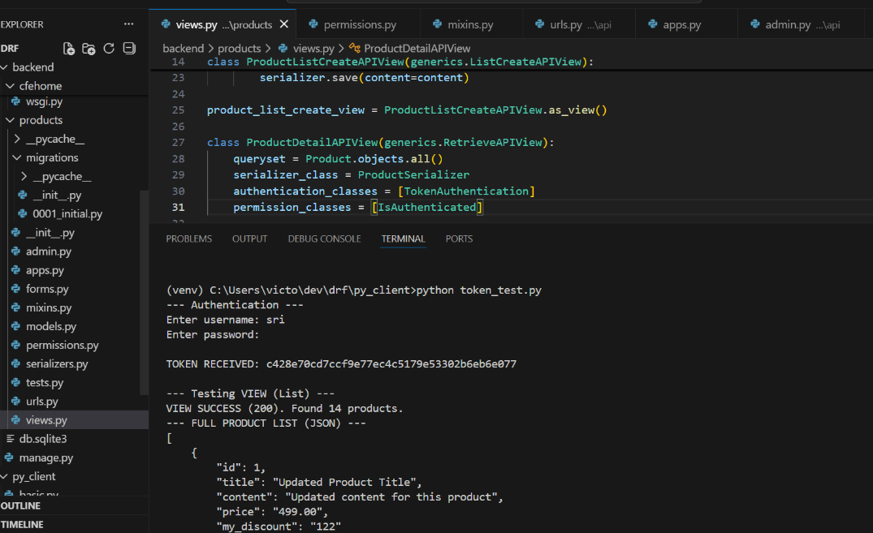

Hence he was not able to delete
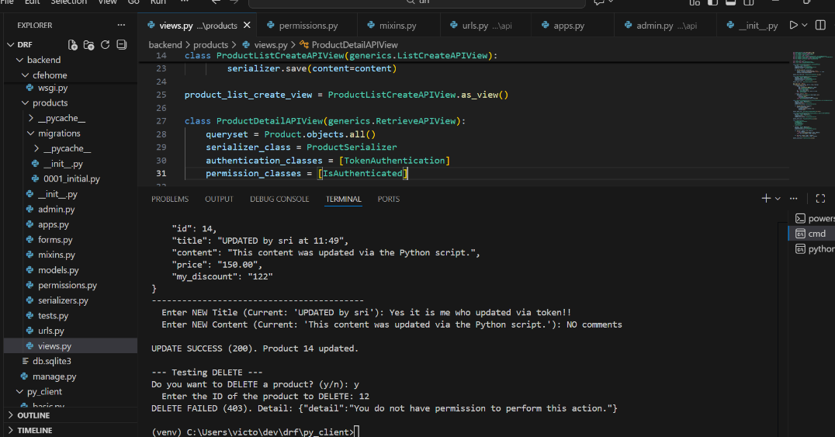

Note:
the problem was that the code was designed to be interactive, but the initial version of the "update" logic didn't actually retrieve the existing data first.
- The script successfully got the token (TOKEN RECEIVED: ...).
- It successfully listed products (VIEW SUCCESS (200)).
- When you asked to update Product 14, the script attempted to make a new, intermediate GET request to the detail URL (/api/products/14/).
- Due to the missing permission class on the backend detail view, the server ignored the valid token and sent back the generic 403 Forbidden error, crashing the interactive process.
Once you added the authentication_classes = [TokenAuthentication] and permission_classes = [IsAuthenticated] to your ProductDetailAPIView, you fixed the backend, allowing the client's continuous, automated use of the token to succeed.

Now lets try deletion with superuser
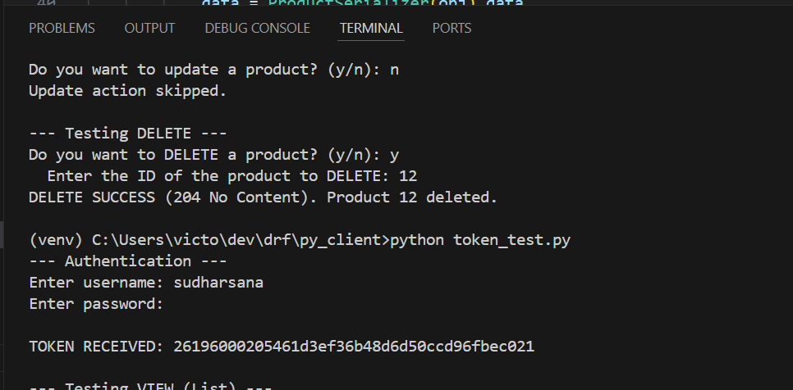
Aftter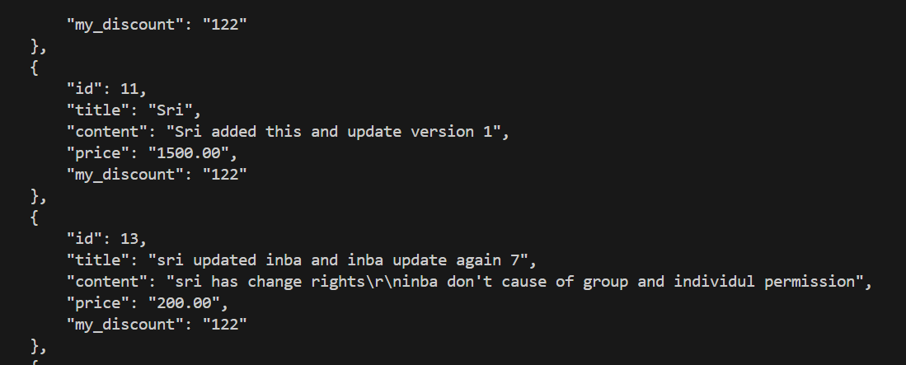
To view in UI
Registeri in admin.py
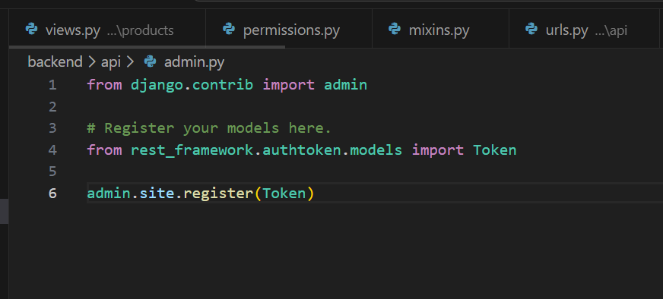
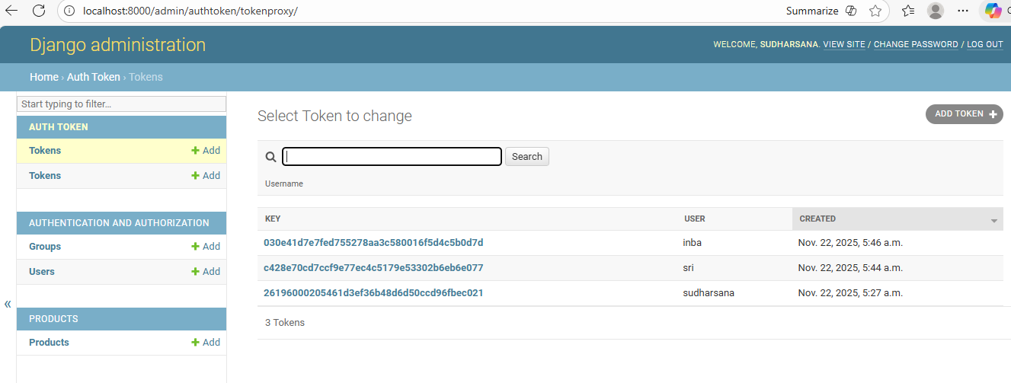

Setting manually expiration time
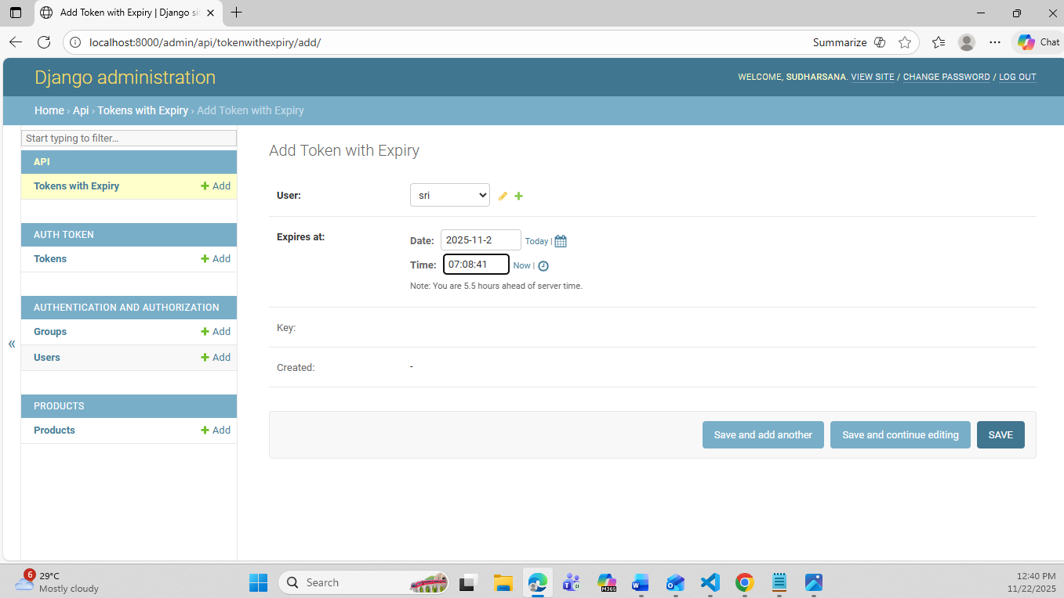

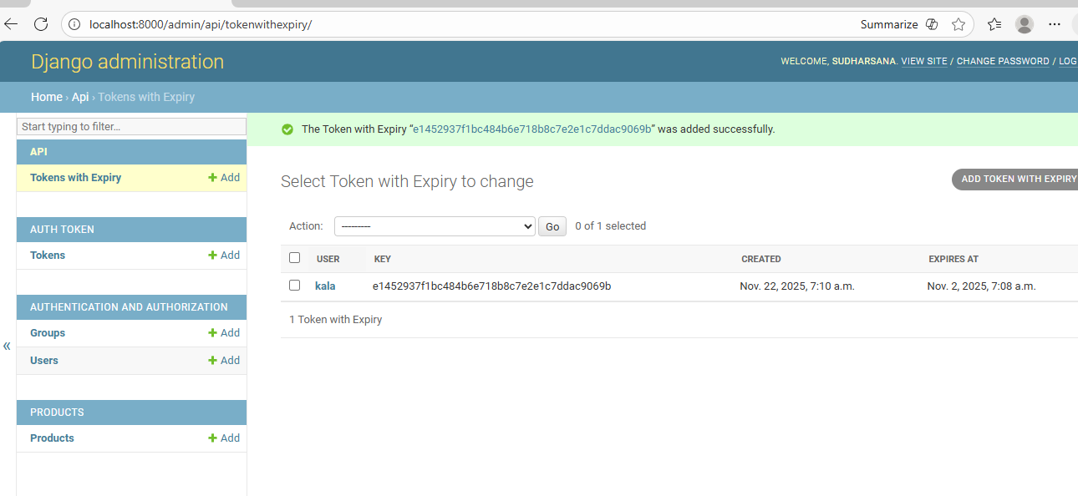
If Token is expired then api calls for that session wont work

To delete the token or add any other token
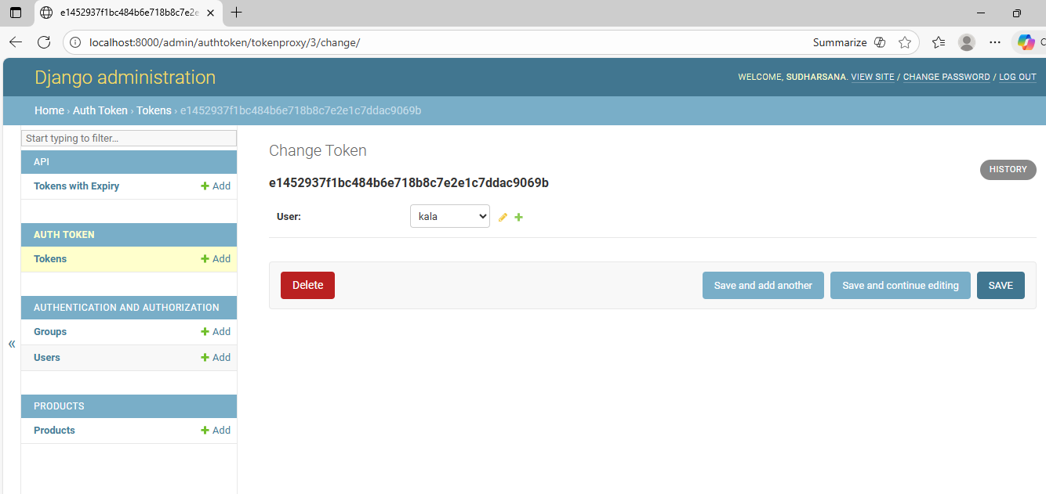
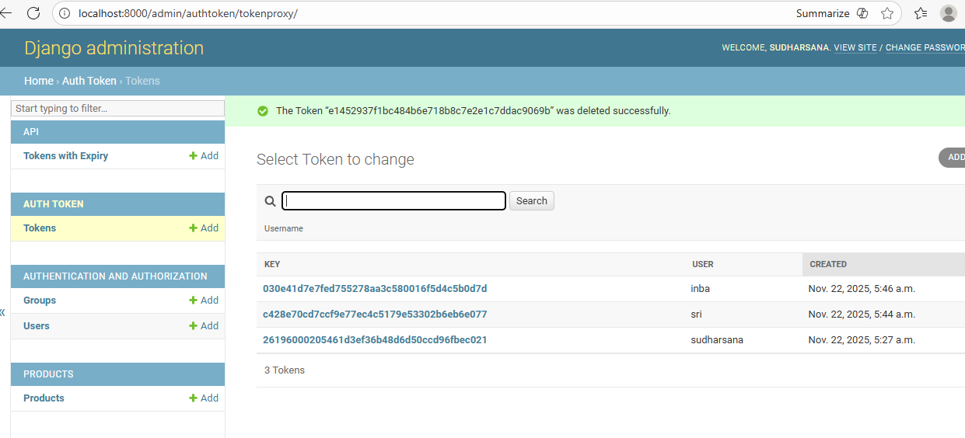

Feature / Aspect | Django (DRF) Token Authentication | Spring Boot (JWT / Token)
Implementation | Provided by rest_framework.authtoken module; simple token per user | Often uses JWT (JSON Web Token) via spring-security
Token Type | Random string (stored in DB) | JWT (self-contained, signed, can include claims)
Storage | Stored in database (Token model) | Stateless; no server-side storage required
Expiration | No expiration by default (can implement manually) | Usually has expiry date embedded in token
Authentication Flow | Client sends Authorization: Token <token> header | Client sends Authorization: Bearer <JWT> header
Revocation | Can delete token from DB to revoke access | Can’t revoke JWT without additional server-side tracking
Security | Depends on token secrecy; must use HTTPS | Signed token ensures integrity; secure, also needs HTTPS
Complexity | Simple to implement | More setup needed (signing keys, filters, JWT parsing)
Use Case | Small/medium apps, quick prototyping | Scalable, stateless, microservices, distributed systems
Integration | Easy with DRF views and permission classes | Integrated with Spring Security filters, annotations

Default DRF Settings
1. What are DRF Default Settings?
Django REST Framework comes with default behaviors for your project.
Example:
- What authentication method to use?
- What permission system to use?
- What throttling (rate limit) to apply?
- What rendering format (JSON) to use?
These defaults live in:
settings.py → REST_FRAMEWORK = { ... }
If you DO NOT configure anything,
DRF uses its built-in defaults.

2. Why do we need DRF settings?
Because instead of repeating code in every view,
we set global behavior in one place.
Example:
Instead of writing this in every view:
authentication_classes = [SessionAuthentication, TokenAuthentication]
permission_classes = [IsAuthenticated]
You configure once:
REST_FRAMEWORK = {
"DEFAULT_AUTHENTICATION_CLASSES": [...],
"DEFAULT_PERMISSION_CLASSES": [...],
}
Now all views follow this rule.
Cleaner → Faster → Fewer mistakes
3. DRF Default (Built-in) Settings
These are what DRF uses if you do NOTHING.
Default Authentication
DEFAULT_AUTHENTICATION_CLASSES = [
'rest_framework.authentication.SessionAuthentication',
'rest_framework.authentication.BasicAuthentication'
]
Default Permission
DEFAULT_PERMISSION_CLASSES = [
'rest_framework.permissions.AllowAny'
]
Meaning:
Anyone can access API without login
Session or Basic auth is used if needed

4. What WE changed
You replaced DRF defaults with your own.
Your updated settings:
Authentication Classes (GLOBAL)
REST_FRAMEWORK = {
"DEFAULT_AUTHENTICATION_CLASSES": [
"rest_framework.authentication.SessionAuthentication",
"api.authentication.TokenAuthentication",
],
Meaning:
✔ Session auth (for admin)
✔ Token auth (for API users)

Permission Classes (GLOBAL)
"DEFAULT_PERMISSION_CLASSES": [
"rest_framework.permissions.IsAuthenticatedOrReadOnly",
]
}
Meaning:
✔ Everyone can read (GET)
✔ Only authenticated users can write (POST/PUT/DELETE)

5. What changed after updating settings?
Feature | Default DRF Behavior | Your Updated Behavior
Authentication | Session + Basic | Session + Token
Permission | AllowAny (no login needed) | Must login for write, read allowed for all
Need to write in every view? | Yes | No (global rules apply)
Security level | Low | High

6. Why did we change these settings?
Because:
- You are building an API
- You need Token Authentication
- You want control over write access
- You don’t want to repeat code in every view

7. Final Simple Explanation
Default DRF settings = open API
Your custom settings = secure API
Postman testing links:
Django_API_Learnings | Postman API Network
ViewSets & Routers
Drf venv
Move to backend to run the server
python manage.py runserver
24/11/25
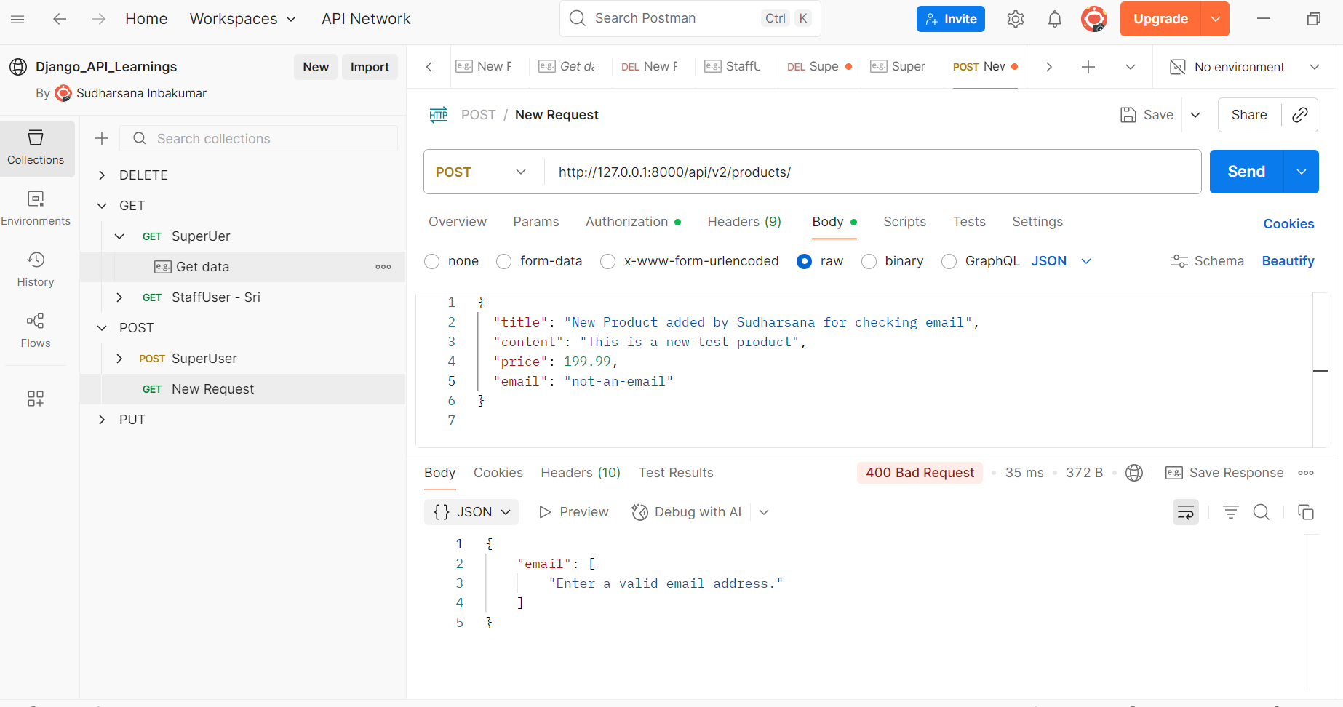

Pagination:
Pagination is a technique used to break up a very large set of data (like all your products) into smaller, manageable "pages" or chunks.
It is a critical performance and usability feature for any API that deals with lots of data.
Eg: Ecom website
The process:
We implemented Django REST Framework's LimitOffsetPagination globally in your settings.py.
- Set the Standard: We told the system to use LimitOffsetPagination and set the default PAGE_SIZE to 10.
- Enforced Limits: Now, when a client (like your browser or Python script) requests the product list, the API does not load all 15 products from the database. It only loads the first 10.
- Provided Navigation: The API wraps the 10 results in a special structure that includes:
  - count: The total number of items available (15).
  - results: The 10 items for the current page.
  - next: A URL (like ...?limit=10&offset=10) that the client can use to easily request the next page of 5 items.
Output:
I have set the page size as “2”
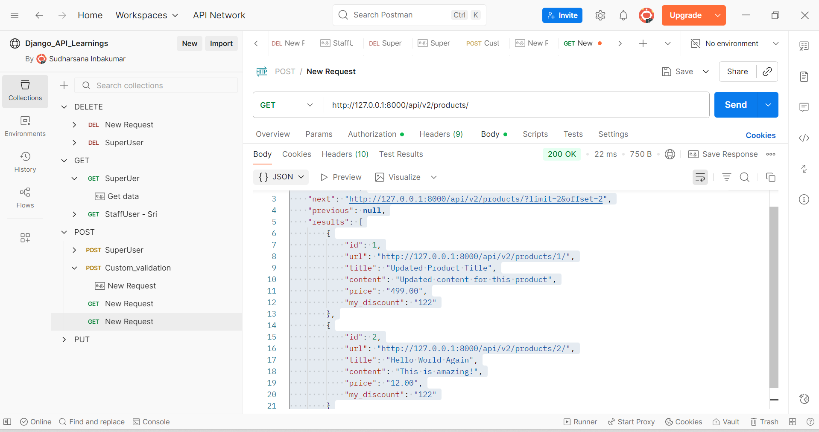

A Django based search for our Product API:
Q-objects in Django are special query tools used to build complex database filters, especially when you need OR, AND, or NOT conditions inside a queryset.

✅ What are Q-Objects?
In Django, filters normally chain with AND logic:
Product.objects.filter(title__icontains="phone", price__lte=500)
This means:
- title contains “phone”
- AND price <= 500
But if you want OR conditions (example: title contains “phone” OR description contains “phone”), normal filters cannot do that.
That’s where Q-objects come in.

✅ Why we need Q-Objects?
To perform:
✔ OR conditions
from django.db.models import Q

Product.objects.filter(
Q(title__icontains="phone") |
Q(description__icontains="phone")
)
✔ AND conditions (explicit)
Product.objects.filter(
Q(is_public=True) &
Q(price__gte=100)
)
✔ NOT conditions
Product.objects.filter(~Q(is_public=True))

✅ Where you used it today
You used Q-objects inside ProductQuerySet.search(), like:
def search(self, query, user=None):
lookup = Q(title__icontains=query) | Q(content__icontains=query)
qs = self.filter(lookup)

return qs_public | qs_user
Here you used OR logic:
- Match title OR content

Simple Explanation
Normal filter | Q-object
Cannot do OR | Can do OR
Uses AND only | Supports OR, AND, NOT
Straightforward filters | Complex logic

Real-life Example
Search for products where
title contains update" OR description contains "update":
Product.objects.filter(
Q(title__icontains="update") | Q(description__icontains="update")
)

If you want, I can also explain Custom QuerySet, Custom Managers, or show a full example of your ProductQuerySet.search() with comments.

1. No Query: http://127.0.0.1:8000/api/search/
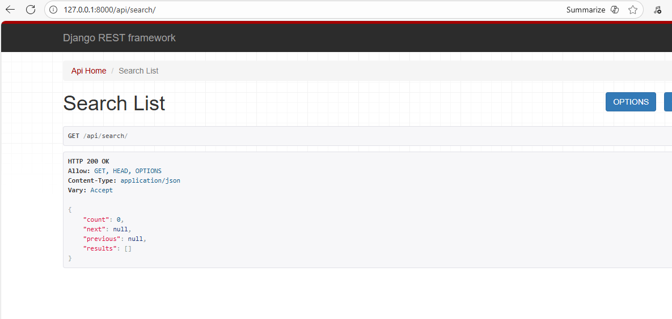
2.Public Search: http://127.0.0.1:8000/api/search/?q=Updated
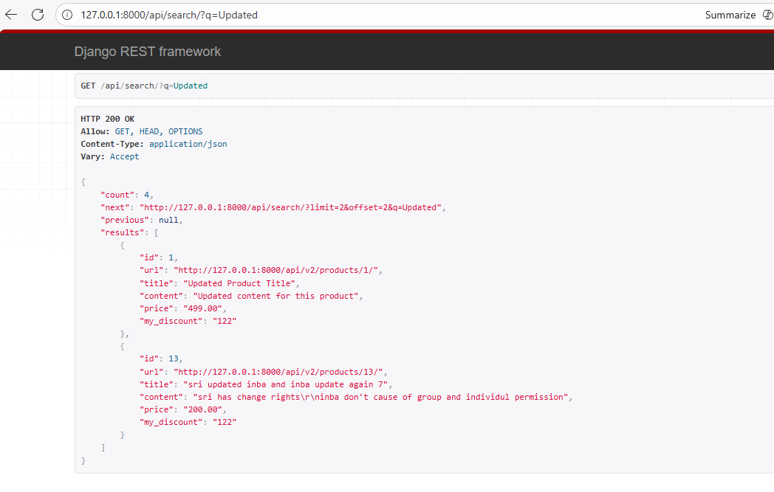

3. Private Search (Login Required) http://127.0.0.1:8000/api/search/?q=Content
Scenario Setup:
- Product 1: Owned by User A (you), Title: "Private Doc Content", public=False.
- Product 2: Owned by User B, Title: "Public Doc Content", public=True.
Parameter | Expected Behavior
q | "Content"
Code Path | The search logic runs two combined lookups: 1. All public matches (Product 2) $\mathbf{OR}$ 2. All User A's matches (Product 1) $\rightarrow$ Distinct results.
Expected Output | The result should contain BOTH Product 1 (your private product) and Product 2 (the public product). The query is successful because it combines the two conditions.

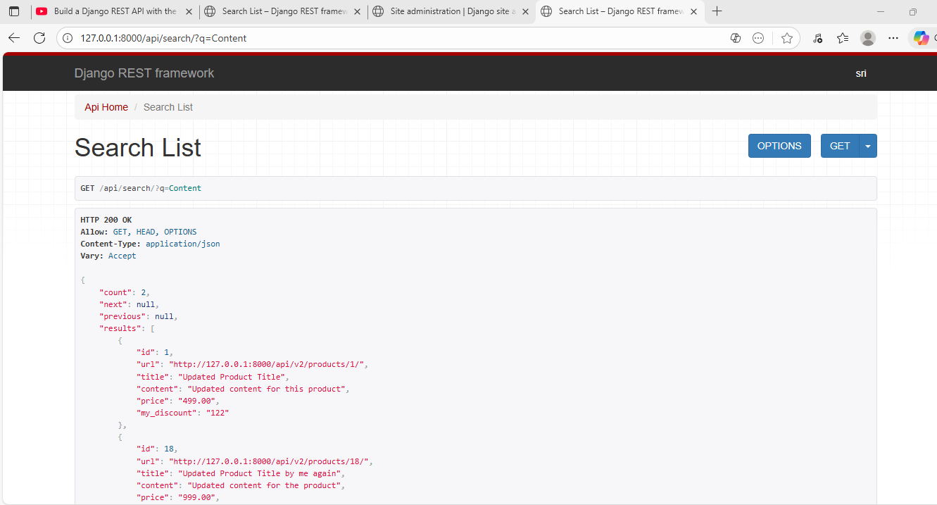

JWT Authentication
JWT is stateless, meaning the server does not store session data. This eliminates session hijacking and reduces server overhead.
Tokens are signed using a secret key or RSA public/private keys, ensuring that they cannot be tampered with or modified.
Short-lived access tokens reduce the impact even if a token is exposed.
Refresh tokens allow the user to securely obtain new access tokens without re-entering credentials.
JWT works well in distributed systems (microservices) because each service can verify the signature independently.
Header, Payload, Signature structure makes it easy to store user identity and claims securely.

Install the package:
djangorestframework-simplejwt
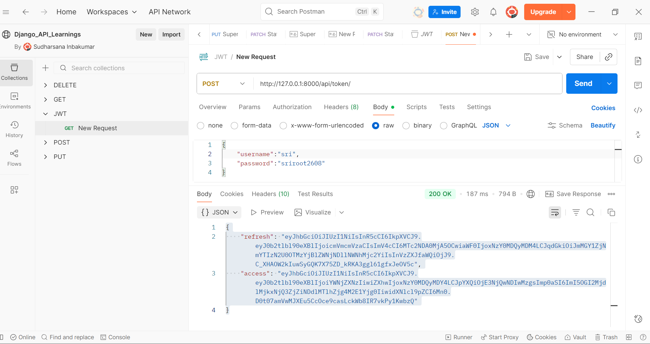
1. What is a JWT Access Token?
A JWT Access Token is a short-lived token that is sent with every API request to prove the user is authenticated.
- It contains user identity + permissions.
- It is included in the HTTP header like this:
Authorization: Bearer <access_token>
- Used to access protected APIs.
- Usually has a short expiry (ex: 30 seconds, 5 minutes).
If the access token expires, the user cannot make authenticated API requests anymore.

2. What is a JWT Refresh Token?
A JWT Refresh Token is a long-lived token used to get a new access token without logging in again.
- It is not sent in every request.
- Only used at the endpoint:
/api/token/refresh/
- Has a longer expiry (ex: days, weeks).
- Helps maintain login sessions securely.
Refresh token = generator for new access tokens.

How They Work Together
Token Type | Purpose | Expiry
Access Token | Authenticate API requests | Short (minutes)
Refresh Token | Get new access token when expired | Long (days)

3. Why JWT is Preferred Over Other Authentication Methods?
Here are the main reasons:

✔ 1. Stateless (No Session Storage Needed)
Unlike traditional sessions, JWT does not store anything on the server.
- No session table
- No server memory used
- Perfect for large, scalable apps and microservices
Makes the system faster and easier to scale.

✔ 2. Highly Secure — Signed & Tamper-Proof
JWTs are signed using:
- HS256 (secret key) or
- RS256 (public/private key pair)
Users cannot modify the token content.
If they try, the signature becomes invalid.
Makes JWT more secure than regular session cookies.

✔ 3. Works Across Multiple Services
JWT can be used in:
- APIs
- Mobile apps
- Microservices
- Frontend frameworks (React, Angular, Vue)
Each service can validate the token without needing a central database.

✔ 4. Supports Short & Long Lifetimes
- Short access token → reduces damage if stolen
- Long refresh token → avoids frequent re-logins
Balanced security + user convenience.

✔ 5. No Cookies Required
Unlike session auth, JWT works cleanly with:
- Mobile apps
- Postman
- API consumers
No cookie management needed.

✔ 6. More Control with Claims
JWT includes embedded information (claims):
- user ID
- roles
- permissions
The server can read these directly from the token.

JWT Structure: Header, Payload, Signature
A JWT (JSON Web Token) is made of three parts, separated by dots:
xxxxx.yyyyy.zzzzz
These represent:
- Header
- Payload
- Signature

1.Header
The header contains metadata about the token:
- The signing algorithm (HS256, RS256)
- Token type (JWT)
Example (before encoding):
{
"alg": "HS256",
"typ": "JWT"
}
After encoding → Base64 string.
The header tells the server how the token was signed.

2.Payload
The payload contains the actual data (claims):
- sub → user ID
- exp → expiration time
- iat → issued at time
- Custom claims (role, email, permissions, etc.)
Example:
{
"sub": "21",
"name": "Sudharsana",
"role": "admin",
"exp": 1732600000
}
This part is not encrypted, only encoded, so it can be read by anyone.
But because it is signed, it cannot be modified without detection.

3.Signature
The signature ensures the token is valid and not tampered with.
It is created using:
HMACSHA256(
base64UrlEncode(header) + "." + base64UrlEncode(payload),
secret_key
)
If the token is changed, the signature will not match, and the server rejects it.
This is what makes JWT secure — you can read it, but you cannot modify it.

Login via JavaScript Client
1.Creating the Frontend Client: Setting up the basic HTML form and the accompanying JavaScript file (client.js) to initiate a login request.
Create a js_client folder and create two sub files:
1.index.html
2.client.js.
Client Server:
cd js_client
python -m http.server 8111

2.Addressing CORS Issues: Identifying the CORS policy block that occurs when the client (running on port 8111) tries to access the API (running on port 8000).
When you try to run the login form, you will get the CORS block because your Django API server (localhost:8000) does not allow scripts from your client server (localhost:8111) to make requests.
Import pip install django-cors-headers
Configure in settings.py

Output:
Navigate to http://localhost:8111 in your browser.
Open the developer console (F12 or Ctrl+Shift+J) and go to the Console tab.
Enter your username and password and click Log In.
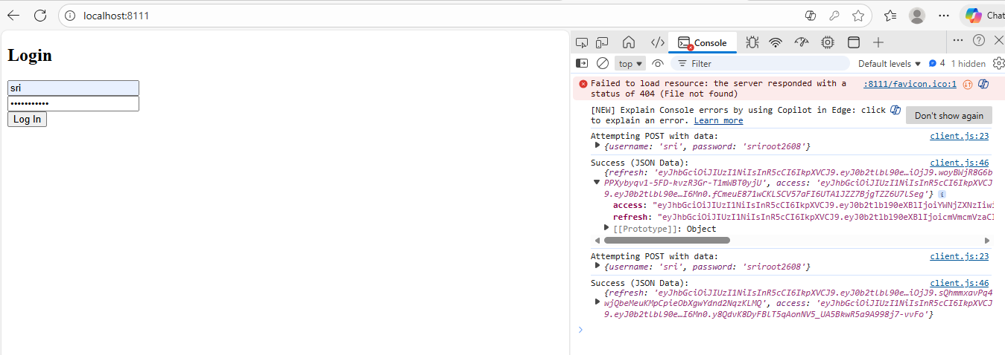
To avoid CORS:
Steps Completed:
- Installed the django-cors-headers package.
- Added 'corsheaders.middleware.CorsMiddleware' to the MIDDLEWARE setting (before CommonMiddleware).
- Configured CORS_ALLOWED_ORIGINS in settings.py to specifically allow http://localhost:8111 (or http://127.0.0.1:8111).
Here is a simple, clear explanation:

What is CORS?
CORS (Cross-Origin Resource Sharing) is a browser security rule that controls which websites are allowed to send requests to your server.
A “cross-origin” happens when:
- Frontend → http://localhost:8111
- Backend → http://localhost:8000
Different port = different origin → browser considers it unsafe.

Why does it throw an error?
Browsers block the request because your JavaScript client is running on 8111, but your Django API is on 8000.
So the browser says:
“This server has NOT allowed this origin (8111).
I will block the request.”
This is called a CORS error.

How to Rectify (Fix) It
You must explicitly allow the frontend origin inside Django.
1. Install the package
pip install django-cors-headers
2. Add to INSTALLED_APPS
INSTALLED_APPS = [
'corsheaders',
...
]
3. Add CORS middleware (must be at the top!)
MIDDLEWARE = [
'corsheaders.middleware.CorsMiddleware',
'django.middleware.security.SecurityMiddleware',
...
]
4. Allow your frontend origin
CORS_ALLOWED_ORIGINS = [
"http://localhost:8111",
"http://127.0.0.1:8111",
]

Result
After this setup:
- Browser sees that your backend allows http://localhost:8111
- Requests pass
- Your JS client successfully receives JWT tokens

